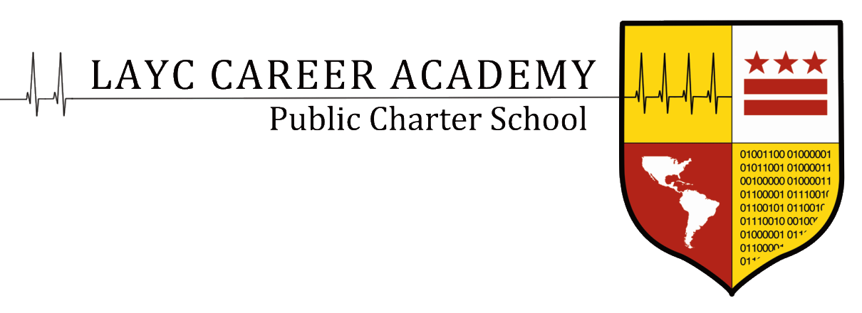

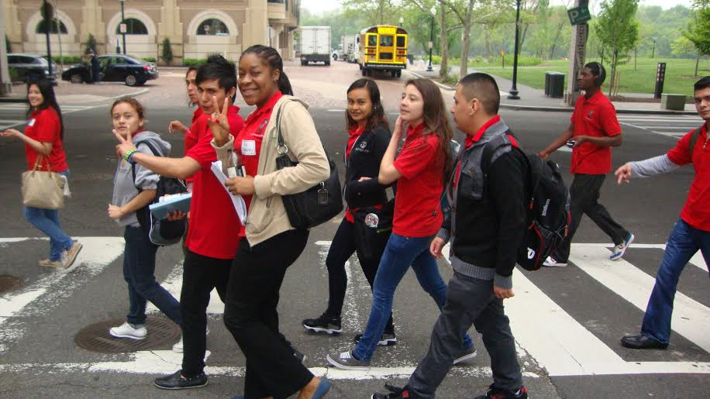

Student Handbook

**Table of Contents**

Mission Statement ……………………………………………….……………………………………………………….. 3

Eligibility ………………………………………………………….………………………………………………………….. 3

Age, Residency

Cost

Required Enrollment Documents

Assessments ………………………………………………………………………………………………................……... 5

NWEA Map & TABE Exams

General Education Development

Accuplacer

Disability Support Services/ Special Education Services ………………………………………………… 5

Grades ………………………………………………………...……………………………………………………………….. 5

Length of Program ………………………………………………………………………………………….…………….. 6

Academic Year ……………………………………………………………………………………………………………… 6

Curriculum and Scheduling …………………………………………………………………………………………… 6

Curriculum at LAYCCA

Daily Schedule

GED Attainment Program

Pre-pathway Program

College Access Pathway

Medical Assistant Pathway

Information Technology Pathway

Phase Information ……………………………………………………………………………………………………….11

Graduation Requirements ……………………………………………………………………………………………12

Course Listings ……………………………………………………………………………………………………………13

Student Support Services…………………………………………………………………………………………......14

Uniform Policy …………………………………………………………………………………………………………….16

Behavioral Protocol ……………………………………………………………………………………………………..18

Anti-Bullying Policy ………………………………………………………………………………………………….... 20

Manifestation Determination Policy for Special Education Students .............................................................27

Appeals Process ………………………………………………………………………………………………………………………28

Attendance Protocol …………………………………………………………………………………………………………………29

Truancy Protocol ……………………………………………………………………………………………………………………. 32

Lost or Stolen Property …………………………………………………………………………………………………………… 33

Deferment ………………………………………………………………………………………………………………………………. 33

Sample Attendance contract ……………………………………………………………………………………………………. 34

Defferment Letter Sample ……………………………………………………………………………………………………….. 35

FERPA Notice …………………………………………………………………………………………………………………………. 36

Policy of Non-Discrimination ………………………………………………………………………………………………….. 37

# Mission Statement

LAYC Career Academy engages and empowers young people between the ages of 16-24 by providing a college preparatory education, career training in high-growth occupations, and college-credit classes.

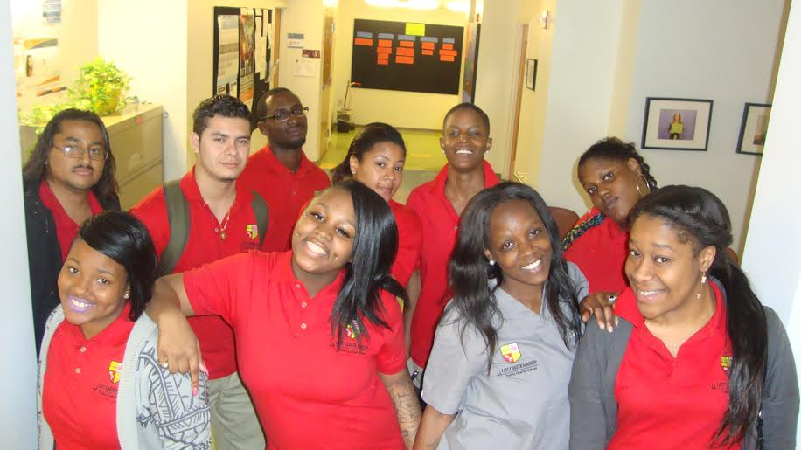

# Eligibility

## Age, Residency

In order to apply to the LAYC Career Academy, the student must be between the ages of 16-24 and a DC resident. *Students who turn 25 while enrolled may continue until the first day of the fall trimester.*

All students are required to complete the enrollment process, which includes the appropriate paperwork, interview, and orientation.

## Cost

The LAYC Career Academy is a public charter school in the District of Columbia and is therefore free to all students.

## Required Enrollment Documents

To enroll in the LAYC Career Academy, all students must provide documents that certify proof of age and proof of residence. Additionally, they must provide vaccination records, a withdrawal form, and transcripts from previous schools.

In order to show **proof of age**, the applicant must provide **ONE** of the following:

* Birth certificate
* A valid driver’s license showing the student’s name
* A valid government or military issued ID showing the student’s name
* A passport
* A valid INS card showing the student’s name
* A valid work permit

In order to show **proof of DC Residency,** the applicant must provide **ONE** of the following:

* A pay stub or tax withholding statement within the last 45 days showing the student’s, parent’s or legal guardian’s name; or
* Official proof of financial assistance (TANF) from the DC government showing the student’s, parent’s or legal guardian’s name; or
* Supplemental Security Income annual benefits notification issued to the person enrolling the student within the past (12) months and indication his/her current address; or
* Current valid court order indicating that the student is a ward of the District of Columbia

**OR**

In order to show **proof of DC Residency**, the applicant must provide **TWO** of the following:

* A valid unexpired DC motor vehicle registration showing the student’s, parent’s or legal guardian’s name
* A valid unexpired lease or rental agreement with paid receipts or cancelled checks for payment of rent showing the student’s, parent’s or legal guardian’s name
* A valid DC driver’s license showing the student’s, parent’s or legal guardian’s name
* A DC utility bill (gas, water, or electric) and paid receipts or cancelled checks for payment of rent showing the student’s, parent’s or legal guardian’s name

Note: Cable, cell or telephone bills are not accepted.

# Assessments

## NWEA Map Exam & TABE Assessment

LAYCCA uses the NWEA and TABE reading tests to determine skill levels for placement and promotion. NWEA and TABE testing occurs three times a year.

If a student feels as though the results of the test were not indicative of his abilities or the student makes substantial growth in a short amount of time, s/he can request a retest between sessions. Students should see advisors regarding this process. No student may take the NWEA reading test more than four times in any one year.

## General Education Development

Credential seeking students will take the practice GED. This will be used to determine GED preparation. See the academic program section for more information on scoring and timelines.

## -Accuplacer

The Accuplacer test is used to determine college readiness, as directed by UDC-CC and Trinity Washington University. Test scores must meet entrance scores set by the institution.

# Disability Support Services/ Special Education Services

Students in need of additional academic support should bring applicable documents to the enrollment interview. The Special Educational Coordinator will work with students individually to address learning needs.

# Grades

LAYCCA is a mastery-based program. Traditional grades (A, B, C, D, F) are not used in the program. Students are able to monitor their mastery of standards in real time through the ActiveGrade portal.

# Length of Program

LAYC Career Academy promotes students through our phase program based on scores on the NWEA reading test. For this reason, all students should expect to take a reading course each session. Students who do not have a high school credential must complete the GED courses prior to taking the pathway courses. The program may last from 8 months to 7 years based on the level at which the student enters, participation in class, attendance in school, and other factors.

# Academic Year

LAYCCA operates year-round. There are three trimesters in each academic year. Within each trimester there are two sessions. Courses vary from session to session.

**Academic Year**

Trimester 1

Aug- Dec

Session 1

Session 2

Trimester 2

Jan- March

Session 1

Session 2

Trimester 3

April-Aug

Session 1

Session 2

# Curriculum and Scheduling

Prior to each session start, students meet with advisors to review testing data, academic performance, attendance, and goals. Credential-seeking students are placed in the GED classes. Pre-pathway students are able to create preferred schedules based on their needs and pathway. Students who have entered the pathway courses take a pre-determined set of classes that will best accelerate their progress through the program. All student schedules are subject to approval by the Director of Curriculum and Instruction. Only the Director of Curriculum and Instruction may authorize changes to schedules after the master schedule is published.

## Curriculum at LAYCCA

The curriculum at LAYCCA is aligned with the Common Core State Standards. Credential- seeking students work closely with MyGED, the online portal, and other GED preparation materials. Instructors in the pre-pathway program create rich and innovative lessons based on the Common Core State Standards that also relate to the lives of our students. There are no set curricular resources for the pre-pathway program. Students in the pathway program follow industry-recognized curriculum.



## Daily Schedule

9:00-9:55 First Period

10:00-10:55 Second Period

11:00-11:55 Lunch

12:00-12:55 Third Period

1:00-1:55 Fourth Period

2:00-2:55 Fifth Period

## 

## GED Attainment Program

|  |  |  |
| --- | --- | --- |
| Practice GED | Math | New students will take the math portion of the practice GED prior to the beginning of school. This should be scheduled at the same time as the NWEA reading exam. |
| Science and Social Studies | New students will take this during normal class times during the first full week of classes. |
| Reading | New students will take this during normal class times during the second full week of classes. |
| *All students will complete the practice GED as a final exam at the end of each trimester.* | |

|  |  |  |
| --- | --- | --- |
| Scoring and Timelines | 155+ on all subjects | Students take the GED on the next available testing date. |
| 145-155 in any subject | Students are urged to take the GED at the end of the trimester |
| Below 145 in any subject | Students will spend at least 2 trimesters for GED prep at LAYCCA, in addition to the time required for pathway training. |

|  |  |  |  |  |
| --- | --- | --- | --- | --- |
| Scheduling | GED Subgroup 1 | 9am-11am Reading and Social Studies | 12pm-2pm Science and Math | 2pm-3pm Elective |
| GED Subgroup 2 | 9am-11am Science and Math | 12pm-2pm Reading and Social Studies | 2pm-3pm Elective |
| * Students in the GED subgroup will continue with GED courses until they have earned their credential. * During the second session of the trimester, the elective will be replaced with a GED writing class. | | | |

|  |  |
| --- | --- |
| Testing | Students will take the test on 3 pre-determined dates each year. |
| LAYCCA will pay for the first attempt at the test. |
| Per DC regulation, students must take all four sections before they are permitted to re-take any session. |
| Students who do not pass at the first attempt will meet with the GED team to develop a plan for re-take. The Director of Curriculum and Instruction will approve that plan. |

## Pre-pathway Program

Many students come to LAYCCA with a high school credential but without the reading skills to succeed in the pathway programs. Students seeking success in our pathway program must read at a minimum of an eleventh grade reading level in order to be access the information. Therefore, students who are credentialed but are not reading at an 11th grade reading level enter our pre-pathway program. These students take classes designed to improve reading ability and technical skills.

|  |  |  |  |  |
| --- | --- | --- | --- | --- |
| Sample student schedules |  | Pre-MA | Pre-IT | Pre-College |
| 9:00-9:55 | Reading for MA | Reading for IT | NWEA Reading |
| 10:00-10:55 | Elective | IC3-KA | NWEA Reading |
| 12:00-12:55 | Writing | Elective | Elective |
| 1:00-1:55 | Medical Terminology | Writing | Pre-College Bio |
| 2:00-2:44 | Anatomy | NWEA Reading | College Prep Math |

## College Access Pathway

Students with a desire to gain college credits must apply for the Dual Enrollment Pathway. Students may do this in conjunction with the Medical Assistant or Information Technology Pathway.

Students in the Dual Enrollment Program take courses through Bard College, Trinity Washington University, or University of the District of Columbia Community College. Students must earn six college credits if they wish to graduate through the Dual Enrollment Pathway.

## Medical Assistant Pathway

The Medical Assistant (MA) Program is comprised of two main parts: classroom instruction and internship. The classroom instruction is measured in hours in the classroom and evaluated by written exams and demonstrated skills. The program includes eight modules. Students must spend a minimum of 300 hours in the classroom and 300 hours in an internship placement to complete the MA program. Students in the Medical Assistant pathway spend 2-4 hours in Medical Assistant training per day. Once students progress to internships, they will typically spend 2-4 days at the internship site and the remaining days at LAYCCA.

Medical Assistant courses are open to students who reach 228 or higher on the reading portion of the NWEA. Students who have yet to qualify for the MA courses may take MA-focused classes such as Science for MA or Reading for MA.

Students who have prior training in the medical field should speak to the Medical Assistant Instructor to design an individual plan for success.

## Information Technology Pathway

The Information Technology (IT) program begins with the IC3 exam. The recommended preparation time for this is 75 hours or 25 hours per exam. Students are able to move through this program at their own pace. After earning the IC3, students in the IT pathway continue in the program by earning the A+ credential. This includes a series of two tests, with a recommended preparation time of 300 hours.

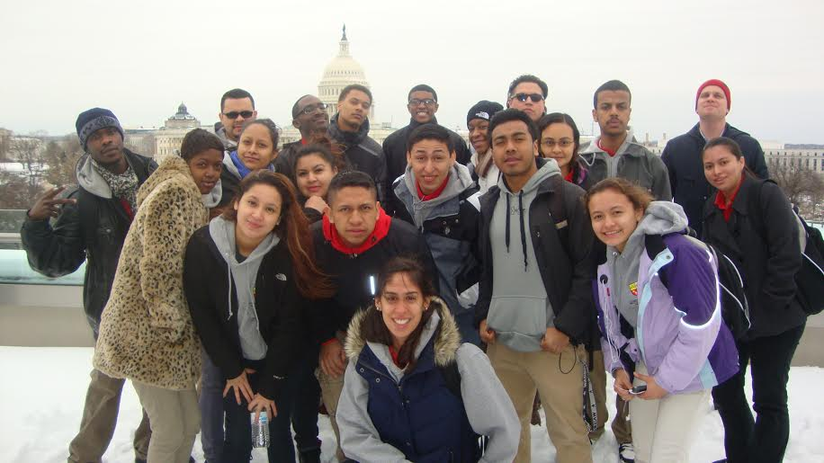

# Phase Information

*Reminder, students are placed into phased based on their NWEA reading score. Phases are not affected by high school credential status.*

Students in the **Discovery** phase…

* Read below a 6th grade level
* Have an NWEA reading score less than 223
* Courses typically include reading, writing, and math
* Do not take courses in their career pathway

Students in the **Demonstration** phase…

* Read between a 6th and 9th grade level
* Have an NWEA reading score between 224 and 233
* Courses typically will focus on reading, writing, and math
* Work on the IC3
* May begin a course in their pathway, with a focus on increasing core skills

Students in the **Exploration** phase…

* Read at least at a 9th grade level
* Have an NWEA reading score between 234 and 237
* Earn their IC3
* Begin taking courses in their pathways

Students in the **Application** phase…

* Read above an 11th grade level
* Score between a 238 and 240 on the NWEA reading test
* Have earned their IC3
* Take significant coursework in their pathway
* May take supplemental courses in writing or math as needed or desired

Students in the **Commencement** phase…

* Score at least a 2750 on the practice GED or score at least 241 on the NWEA reading test
* Obtain GED if necessary
* Spend significant time in internships or college courses

# Graduation Requirements

In order to enjoy the privileges and honors of being a LAYCCA graduate, the student must complete the following:

* Possess a high school credential
* Earn the IC3 computer credential
* Complete the A+ program (including internship), the Medical Assistant program (including internship), or earn 6 college credits
* Earn a minimum of a 241 on the NWEA reading test

# Course Listings

|  |  |  |
| --- | --- | --- |
| GED Program | Pre-Pathway Program | Pathway Program |
| GED Science  GED Social Studies  GED Writing  GED Math  GED Reading  GED Test Taking Strategies | Reading for IT  Reading for MA  Reading for College Readiness  Math for Career Readiness  College Prep  Medical Terminology  Human Anatomy  Biology  Introduction to Medical Assistant  IC3 | Reading  A+  College Biology  Advanced Medical Assistant  Dual Enrollment |

## Electives

Below is a sampling of electives that have been offered. Students should take an elective each session. For more information on the electives being offered, please contact the Director of Student Support Services.

* Yoga
* Music
* Music appreciation
* Photography
* Metro Teen Aids
* College Summit
* Art
* Happiness
* Healthy Relationships
* Poetry
* Rap

Student Support Services

The Student Support Department (SSD) serves the students of the LAYC Career Academy by providing students with the skills and knowledge that will support and guide students in their journey to become productive and responsible students, employees and citizens in their communities. The SSD is made up of Student Support Specialists (S3), Electives Coordinator, Master of Social Work Interns and community partners through various grants.

The S3 student relationship allows students to have one identified staff person they can go to when they are in need. The S3s are present to work with students in a partnership, providing ongoing motivation and support to overcome obstacles and achieve their goals.

The SSD is a place where students can go when they are in need of services, a safe place to talk and a place to refocus. The SSD is not to be abused and is not a place to hang out when students do not want to be in class. Students should stay in the SSD office for no more than ten minutes unless a scheduled meeting is taking place.

In addition to the above, S3s provide the following services:

* Support students on caseload
* Consistently establish effective rapport with students
* Assure continuing awareness of school policies
* Communicate necessary information to students, colleagues, and families, where applicable, regarding student progress and student needs
* Consult with instructors, school staff, and administrators regarding the student’s social and emotion needs
* Identify and host workshops that would benefit students’ emotional/ behavioral growth while encouraging success and enhance student life and culture
* Crisis intervention
* Home visits
* Uniform distribution
* Transportation assistance
* College and career counseling
* Financial aid
* Assistance with documentation such as residency
* Other supports as needed

**Counseling**

The SSD provides individual counseling to students in need upon request. In addition to the Community Schools counselor that provides services on a weekly basis, LAYCCA receives support through Catholic University’s Master of Social Work Interns. The interns are present three times a week to offer individual and group services. Students are identified by S3s for services.

**Breakthrough Class**

The SSD develops non-cognitive skills to cultivate tenacity and persistence through the offerings of Breakthrough (elective) classes. The classes are required for all students and are built into their daily schedules. Some classes being offered include yoga, rap, poetry, music, capoeira, healthy cooking, fitness and art. In addition to Breakthrough classes, students participate in Life Skills courses based on the curriculum, Overcoming Obstacles, which teach skills that empower students to use their past as a motivator towards success.

**youthConnect Partnership**

Through youthConnect, LAYCCA has partnered with some of the area’s most successful nonprofits including Metro Teen AIDS, College Summit, Urban Alliance, KIPP, and LAYC. These organizations provided professional development for staff, career preparedness workshops, health education, mentoring for students, and professional development through funding provided by Venture Philanthropy Partners and the Social Innovation Fund.

Specific to the SSD, LAYC has a Promotor, intensive case manager and youth advocate, in –house at the LAYCCA. Every LAYCCA student is screened to participate in the Promotor Pathway. The Promotor provides additional support to students in the community. Metro TeenAIDS, Urban Alliance and College Summit provide a series of workshops through Breakthrough Classes.

**Community Schools Grant**

LAYCCA is one of sites for the Community Schools program. This program operates from a neighborhood/school-centered model in order to provide services to students from LAYCCA, YouthBuild Public Charter School, LAYC’s WISE program and The Next Step Public Charter School. Students received mental health services, truancy prevention and support services, and health and fitness workshops.

At the LAYCCA, bilingual mental health services are provided once a week to about 10 students. Students have participated in a youth retreat with a goal of providing input on how schools can better keep students engaged. The Community Schools grant supports the LAYCCA’s fitness and nutrition initiatives.

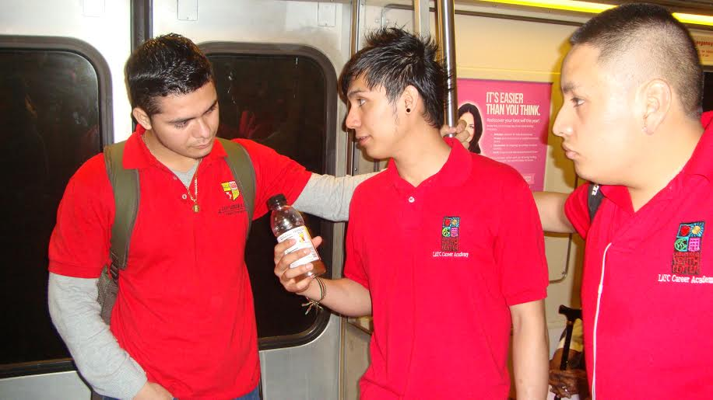

**Uniform Policy**

*Description*

The LAYC Career Academy believes there are many benefits to wearing uniforms; therefore, uniforms must be worn daily. Every attempt will be made to assist students in procuring the uniforms, but the responsibility does lie with the student to remain in compliance.

The uniform consists of the red uniform shirt (provided by LAYCCA) and black, dark blue, or khaki pants. In the case of cold weather, students may wear a long-sleeve shirt under the uniform shirt.

Any student who wears gang paraphernalia to the school will be asked to leave the building. This will count as an unexcused absence. The student will also be reported to the Gang Intervention Unit with the DC police department.

The school will provide two uniform shirts to each student. Students are able to purchase additional shirts from the Director of Operations. LAYCCA also provides uniform pants to students in need.

*Enforcement*

If students do not have a uniform, they should report to the S3 office. The S3s will determine the reasons for the lack of uniform. If the student is defiantly not wearing the uniform, he/she will be sent home. If the student is in need of assistance, the S3s will provide a reasonable amount of support.

**Student Support Department Protocol**

*If student directs aggression toward teacher/student, student is sent home immediately until meeting with Administration and/or Instructor.

If the student is not in immediate need, the Student Support Department is to be used during office hours or by individual appointment only.

Student Support Office is NOT to be used for independent study, testing or any other academic support

**Behavior Protocol**

Purpose

The LAYC Career Academy (LAYCCA) is designed to give students the opportunity to gain skills and training to become contributing members of society. Students will be held to the same standard that they will be held in the workplace.

Scope

Students will be held accountable for their behavior at any time that they are representing LAYCCA. This includes anytime the student is on school grounds, when the student is off school grounds at a field trip or other school sponsored activity, and anytime the student is wearing the LAYCCA uniform.

Concerning Behavior Protocol

A student's behavior becomes a concern when there is a disregard for the learning of the student or the learning of others. When the behavior becomes concerning, LAYCCA will put forth the best effort to abide by the following process:

Level 1: A meeting will be held to discuss the student's concerning behavior. The student will receive a phone call, email, text, and/or letter addressed to the parent/guardian (if under 18) telling the student that a meeting will take place to discuss the behavior. This meeting will be held with the student, an instructor, and a member of the Student Support Office. A plan will be developed to both hold the student accountable for the behavior, as well as investigate what supports can be implemented so that the school can assist the student.

Level 2: If the behavior continues to be concerning, a meeting will be held with the student and a member of the administration. Once again, the behavior will be discussed and a plan will be created for improvement.

Level 3: If the behavior persists, the student will be recommended for suspension or expulsion. Details and procedures of the expulsion process, as well as the rights of the student, are detailed by the DC Public Charter School Board.

It is the school's position that students deserve a chance at redemption and reentry. Whenever possible, prevention, intervention, and remediation strategies will be used. Therefore, students will typically be able to reapply the following trimester. If a student is given the option to return, he/she will reenter with a behavior contract. The contract will include conditions for return that may include, but are not limited to, the following:

* + extra academic work
  + therapy or counseling
  + referral to substance abuse counseling services
  + change to schedule
  + anger management courses
  + attendance intervention
  + daily behavior monitoring
  + mediation
  + mentoring
  + social skills instruction
  + referral to community based organizations

Extreme or Recurring Behavior

There are behaviors that may warrant the school to take measures beyond above protocol. The school reserves the right to respond to the behavior in a way that benefits the student and the larger student body.

Threats/Fighting

Any student who uses words or actions to intentionally harm, force, coerce, threaten, intimidate, or any other comparable conduct which causes or attempts to cause severe physical injury to any member of the Career Academy community will be immediately expelled and may also be barred from the premises.

Physically fighting with a member of the LAYCCA community will result in suspension and possible expulsion.

Weapons

A weapon is defined as “anything used or carried to harm others”. Carrying a weapon anywhere on school or LAYC property will result in suspension and possible expulsion.

Vandalism

Vandalism and graffiti are taken very seriously at LAYCCA. If it is clear who has done the graffiti, that student will be suspended and possibly expelled. Gang-related graffiti on school property and student notebooks will be reported to the gang prevention unit of the DC Police Department.

Possession

Possession of drugs or alcohol on school or LAYC property will result in suspension and possible expulsion. The student may not be able return to class until involved parties participate in a discussion regarding substance abuse counseling.

**Anti-Bullying Policy**

The LAYC Career Academy PCS (LAYCCA) recognizes that a school that is physically and emotionally safe and secure for all students promotes good citizenship, increases student attendance and engagement, and supports academic achievement. To protect the rights of all students and groups for a safe and secure learning environment, LAYCCA prohibits acts of bullying, harassment, and other forms of aggression and violence. Bullying or harassment, like other forms of aggressive and violent behaviors, interferes with both a school’s ability to educate its students and a student’s ability to learn. All administrators, faculty, staff, parents, volunteers, and students are expected to refuse to tolerate bullying and harassment and to demonstrate behavior that is respectful and civil.

A key responsibility of LAYCCA is to provide services in a respectful and positive environment. Acts of bullying, harassment and intimidation are an attack on core LAYCCA values. Thus, to facilitate our mission, LAYCCA has established this comprehensive bullying prevention policy. This policy protects the dignity and safety of the LAYCCA community and describes prevention strategies to identify and prevent incidents by connecting youth to necessary services. LAYCCA will promptly report and investigate all incidents of bullying, harassment and intimidation and provide appropriate remedies for victims of an incident.

This policy serves as LAYCCA bullying prevention plan.

Definitions

(1) “Bullying” means any severe, pervasive, or persistent act or conduct, whether physical, electronic, or verbal that:

(A) May be based on a youth’s actual or perceived race, color, ethnicity, religion, national origin, sex, age, marital status, personal appearance, sexual orientation, gender identity or expression, intellectual ability, familial status, family responsibilities, matriculation, political affiliation, genetic information, disability, source of income, status as a victim of an intrafamily offense, place of residence or business, or any other distinguishing characteristic, or on a youth’s association with a person, or group with any person, with one or more of the actual or perceived foregoing characteristics; and

(B) Shall be reasonably predicted to:

(i) Place the youth in reasonable fear of physical harm to his or her person or property;

(ii) Cause a substantial detrimental effect on the youth’s physical or mental health;

(iii) Substantially interfere with the youth’s academic performance or attendance; or

(iv) Substantially interfere with the youth’s ability to participate in or benefit from the services, activities, or privileges provided by an agency, educational institution, or grantee.

A “**target**” is often a person who suffers from destructive acts, either emotionally or physically. Students who are the target of a bully experience negative emotions. Feelings of persecution prevail over feelings of safety and confidence. Fear, anger, frustration, and anxiety may lead to ongoing illness, mood swings, withdrawal from friends and family, an inability to concentrate, and loss of interest in school. If left unattended, the targeted student may develop attendance and/or discipline problems, fail at school altogether or, in the worst cases; they may become suicidal, retaliatory and violent.

A “**bystander**” is a person who observes a conflict or unacceptable behavior. It might be something serious or minor, one-time or repeated, but the bystander knows that the behavior is destructive or likely to make a bad situation worse. Targets often perceive bystanders as being in collusion with bullies. Bystanders are very different from either targets or bullies mainly because they make a decision to stay on the outside of the situation. Whereas victims and bullies are directly involved, bystanders think that avoiding the conflict altogether is either the right move or the best thing for them personally.

Sexual harassment is a form of sex discrimination, which is prohibited by LAYCCA. In addition, harassment based on any of the above-protected categories is prohibited. Discrimination in violation of the aforementioned laws will not be tolerated. Violators will be subject to disciplinary action.

“Harassment” is conduct that meets all of the following criteria:

* It is reasonably perceived as being dehumanizing, intimidating, hostile, humiliating, threatening, or otherwise likely to evoke fear of physical harm or emotional distress;
* It is directed at one or more students;
* It is conveyed through physical, verbal, technological or emotional means;
* It substantially interferes with educational opportunities, benefits, or programs of one or more students;
* It adversely affects the ability of a student to participate in or benefit from the charter school’s or public school’s educational programs or activities because the conduct, as reasonably perceived by the student, is so severe, pervasive, and objectively offensive as to have this effect; and,
* It is based on a student’s actual or perceived distinguishing characteristic (see above), or is based on an association with another person who has or is perceived to have any of these characteristics.

Title IX regulation requires schools to implement specific and continuing steps to protect students and others against discrimination on the basis of sex. Bullying and harassment also include forms of retaliation against individuals who report or cooperate in an investigation under this policy. Such behaviors are considered to be bullying or harassment whether they take place on or off school property, at any school-sponsored function, or in a school vehicle or at any time or place where a youth’s imminent safety or over-all well-being may be at issue.

**Identification of Behavior Infractions and Implementation of Policy**

The scope of this policy includes the prohibition of every form of bullying, harassment, and cyberbullying/harassment, whether in the classroom, on school premises, immediately adjacent to school premises, when a student is traveling to or from school (portal to portal), or at a school-sponsored event, whether or not held on school premises. Bullying or harassment, including cyberbullying/ harassment, that is not initiated at a location defined above is covered by this policy if the incident results in a potentially material or substantial disruption of the school learning environment for one or more students and/or the orderly day-to- day operations of any school or school program.  The Public Charter School Board (PCSB) expects students to conduct themselves in a manner in keeping with their levels of development, maturity, and demonstrated capabilities with a proper regard for the rights and welfare of other students, school staff, volunteers, and contractors.

LAYCCA and PCSB believe that a comprehensive health education curriculum, within a coordinated school health framework, helps students attain knowledge and skills vital to school success, a productive workforce and good citizenship. Critical skills include anticipating consequences of choices, making informed decisions, communicating effectively, resolving conflicts, and developing cultural competency.

The LAYCCA recognizes that in order to have the maximum impact, it is critical to provide a minimum of annual training for school employees and volunteers who have significant contact with students on school policies and procedures regarding bullying and harassment. Training will provide school employees with a clear understanding of their roles and responsibilities and the necessary skills to fulfill them.

LAYCCA believes that standards for student behavior must be set through interaction among the students, parents and guardians, staff, and community members of the school, producing an atmosphere that encourages students to grow in self-discipline and their ability to respect the rights of others. The development of this atmosphere requires respect for self and others, as well as for district and community property on the part of students, staff, parents, and community members.

LAYCCA believes that the best discipline for aggressive behavior is designed to (1) support students in taking responsibility for their actions, (2) develop empathy, and respect for those different than themselves and (3) teach alternative ways to achieve the goals and the solve problems that motivated the aggressive behavior. Staff members who interact with students shall apply best practices designed to *prevent* discipline problems and encourage students’ abilities to develop self-discipline and make better choices in the future.

Since bystander support of bullying and harassment can encourage these behaviors, LAYCCA prohibits both active and passive support for acts of harassment or bullying. The staff should encourage students *not* to be part of the problem; *not* to pass on the rumor or derogatory message; to walk away from these acts when they see them; to constructively attempt to stop them; to report them to the designated authority; and to reach out in friendship to the target. Periodic classroom meetings, Restorative Conferences and/or Dialogue Circles should be conducted to teach bystanders how and when to respond to bullying and harassment incidents. Informal classroom discussions and activities designed to provide awareness and increase student connectedness promote a positive shift in peer norms that will support empowered bystanders. When bystanders do report or cooperate in an investigation, they must be protected from retaliation with the same type of procedures used to respond to bullying and harassment.

LAYCCA requires its school administrators to develop and implement procedures that ensure *both* the appropriate consequences *and* remedial responses to a student or staff member who commits one or more acts of bullying and harassment. The following factors, at a minimum, shall be given full consideration by school administrators in the development of the procedures for determining appropriate consequences and remedial measures for each act of harassment or bullying.

**Factors for Determining Consequences**

* Age, development, language and maturity levels of the parties involved
* Degree of harm (physical and/or emotional distress)
* Surrounding circumstances
* Nature and severity of the behavior(s)
* Incidences of past or continuing pattern(s) of behavior
* Relationship between the parties involved
* Context in which the alleged incident(s) occurred. *Note*: In order to ensure students’ perception of fair and impartial treatment, a student’s academic or athletic status is *not* a legitimate factor for determining consequences. Consequences must be perceived as fair and impartial.

**Factors for Determining Remedial Measures Personal:**

* Life skill competencies
* Experiential deficiencies
* Social relationships
* Strengths
* Talents
* Traits
* Interests
* Hobbies
* Extra-curricular activities
* Classroom participation
* Academic performance
* School culture
* School climate and lack of connectedness
* Student-staff relationships and staff behavior toward the student
* Level of consistency in staff responses to bullying or harassing behaviors
* Level of consistency in application or severity of consequences given to  students
* Staff-staff relationships witnessed by students
* General staff management of classrooms and other educational  environments
* Staff ability to prevent and de-escalate difficult or inflammatory situations
* Social-emotional and behavioral supports
* Social relationships
* Community activities
* Neighborhood culture
* Family situation

Consequences and appropriate remedial actions for a student or staff member who engages in one or more acts of bullying or harassment may range from Restorative Conferences and positive behavioral interventions up to and including suspension or expulsion, in the case of a student, or suspension or termination in the case of an employee, as set forth in the school’s approved code of student conduct or employee handbook. School employees will also be held accountable for bullying or harassing behavior directed toward school employees, volunteers, parents, or students.

Consequences for a student who commits an act of bullying and harassment shall vary in method and severity according to the nature of the behavior, the developmental age of the student, and the student’s history of problem behaviors and performance, and must be consistent with LAYCCA’s approved code of student conduct. Remedial measures shall be designed to: *correct the problem behavior*; *prevent another occurrence* of the behavior; and *protect the victim* of the act. Effective discipline should employ a school-wide approach to adopt a rubric of bullying offenses and the associated consequences. The consequences and remedial measures may include, but are not limited to:

* Admonishment
* Participation in a guided reflection process designed to teach alternative  behavior (Dialogue Circle, class discussion, etc.)
* Temporary removal from the classroom
* Loss of privileges
* Referral to Student Support Team (SST)
* Referral to disciplinarian
* Out-of-school suspension
* Legal action
* Expulsion or termination

**Options of Remedial Measures Strategies for Individual Behavioral Change:**

* Framing the aggressive behavior as a failed attempt to solve a real problem  or reach a goal. The adult(s) assists the misbehaving student to find a better  way to solve the problem or meet the goal. (SST meeting, meeting with case manager and/or counselor etc.)
* Restitution and restoration
* Transformative conferencing/restorative justice practices
* Supervised peer support group
* Corrective instruction or other relevant learning or service experience
* Supportive discipline to increase accountability for the bullying offense
* Supportive interventions, including participation of a Student Support team, peer or staff mediation, etc.
* Behavioral assessment or evaluation
* Behavioral management plan, with benchmarks that are closely monitored
* Involvement of school disciplinarian
* Student counseling
* Parent conferences
* Student treatment
* Student therapy

**Strategies for Environmental Change (Classroom, School Building, or School Board):**

* Activities or strategies designed to help the student who engaged in bullying or harassment reflect on the offending behavior, maintaining an emotionally-neutral and strength-based approach
* School and community surveys or other strategies for determining the conditions contributing to harassment, intimidation, or bullying
* Change process to improve school culture
* School climate improvement/improvement in conditions for learning and  instructional pedagogy (incorporation of brain-compatible strategies)
* Adoption of research-based, systemic bullying prevention programs
* Modifications of schedules
* Adjustments in hallway traffic
* Modifications in student routes or patterns traveling to and from school
* Increased supervision and targeted use of monitors (e.g., hallway, cafeteria, area surrounding school grounds)
* General professional development programs for certificated and non-certificated staff
* Professional development plans for staff in key disciplinary roles
* Disciplinary action for school staff who contributed to the problem
* Parent conferences
* Referral to family counseling
* Increased involvement of parent-teacher organizations
* Increased involvement of community-based organizations
* Increased opportunities for parent input and engagement in school initiatives and activities
* Development of a general bullying/harassment response plan
* Peer support groups
* Increase communication with and involvement of law enforcement (e.g., school resource officer, juvenile officer)
* Engage in community awareness events and planning sessions

LAYCCA requires the principal, Angela Stepancic, and/or the principal’s designee, Colette Gardner, are to be responsible for receiving complaints alleging violations of this policy. All school employees are required to report alleged violations of this policy to the principal or the principal’s designee. All other members of the school community, including students, parents, volunteers, and visitors, are encouraged to report any act that may be a violation of this policy. Ms. Stepancic can be contacted at (202) 319-2228 or at [angela@layc-dc.org](mailto:angela@layc-dc.org). Ms. Gardner can be contacted at (202) 319-2228 or at colette@laycca.org.

Reports may be made anonymously, but formal disciplinary action *may not* be based solely on the basis of an anonymous report. LAYCCA requires the principal and/or the principal’s designee to be responsible for determining whether an alleged act constitutes a violation of this policy. In so doing, the principal and/or the principal’s designee shall conduct a prompt, thorough, and complete investigation of each alleged incident. The investigation is to be completed within three (3) school days after a report or complaint is made. If under the age of 18, the parents of the students involved shall receive written notice from the school on the outcome of the investigation (in compliance with current privacy laws and regulations). All reports on instances of bullying and/or harassment must be recorded by the school for annual data review.

LAYCCA prohibits reprisal or retaliation against any person who reports an act of bullying or harassment or cooperates in an investigation. The consequences and appropriate remedial action for a person who engages in reprisal or retaliation shall be determined by the administrator after consideration of the nature, severity, and circumstances of the act.

LAYCCA prohibits any person from falsely accusing another as a means of bullying or harassment. The consequences and appropriate remedial action for a *person* found to have falsely accused another as a means of bullying or harassment may range from positive behavioral interventions up to and including suspension or expulsion. Consequences and appropriate remedial action for a *school employee* found to have falsely accused another as a means of bullying or harassment shall be in accordance with school policies, procedures, and agreements.

LAYCCA requires school officials to annually disseminate the policy to all school staff, students, and parents, along with a statement explaining that it applies to all applicable acts of harassment and bullying that occur on school property, at school-sponsored functions, or on a school bus. The chief school administrator shall develop an annual process for discussing the school district policy on harassment and bullying with students and staff.

**Manifestation Determination Policy for Special Education Students**

Within ten school days after the date on which the decision to change the placement is made the LAYC Career Academy shall conduct a “manifestation determination” of the relationship between the student’s disability and the behavior subject to the disciplinary action.

The review of the relationship between a student’s disability and the behavior subject to the disciplinary action shall be done in a meeting by the student, parent(s) if available, and members of the IEP team. The team shall review all relevant information in the student’s file, including the IEP, teacher observations and information provided by the parent to determine:

1. If the conduct was caused by or had a direct and substantial relationship to the child’s disability;
2. If the conduct in question was the direct result of the district’s failure to implement the student’s IEP. Or,

3.If the team determines that the behavior resulted from any of the above, the behavior must be considered a manifestation of the student’s disability and the contemplated disciplinary action shall not proceed.

If the team determines, specifically, that the conduct was the direct result of the school's failure to implement the IEP, the LAYCCA ​will take immediate action to remedy the deficiencies

**Appeals process**

**Mediation**

LAYC Career Academy encourages the use of mediation when disputes between students and/or parents and staff occur. The Executive Director, his/her designee, or the Principal will meet with the student and/ or parent or secure the services of a mediator when appropriate.

Participation in mediation or meetings does not waive a student or parents’, right to proceed with the formal complaint process or corrective procedure set forth below.

**Filing a Complaint**

* An appeals process is available to all students and/or parents who would like to appeal a decision made by LAYCCA and/or its staff.
* Such party who is not satisfied with the outcome of the initial investigation may appeal to the designated higher-level authority
* Appeals must be made within 30 days of the conclusion of the initial investigation
* The secondary investigation shall be completed within 30 days of receipt of appeal, unless:
  + Circumstances require additional time to complete a thorough investigation
  + The higher-level authority sets forth those circumstances in writing
  + The additional time is not to exceed 15 days
* Students/ parents may also appeal to the LAYC Career Academy Board of Directors
* Those filing an appeal shall be informed of the right to seek further redress under the Human Rights Act.

**Attendance Protocol**

**Personal Time Off (PTO)**

*Personal Days*

Every student receives 5 Personal Days each trimester. In order to take a Personal Day, the student must do the following:

1. Contact the SSD via text, email or phone before 8:55am to inform of absence.
2. Arrange with instructors to complete all missed assignments.

Note: After a student uses his 5th Personal Day, s/he will be place on an Attendance Contract.

*Excused Leave*

Each student has the ability to take Excused Leave in emergency situations.

1. Receive approval from S3 and Advisor.
2. Bring institutional documentation to support absence.
3. Arrange with instructors to complete all missed assignments.

*Unexcused Leave*

Any student with Unexcused Leave will be placed on an Attendance Contract.

1. If a student exhausts all Personal Days and cannot provide documentation for any absence, this is considered Unexcused Leave.
2. If a student accrues 5 days of Unexcused Leave, s/he may be disenrolled from the Career Academy.

***Normal Hours***

*Arrival time: 8:55am*

1. A student is considered tardy at 8:56am
2. If a student is tardy three times in a session, the student will be placed on an Attendance Contract via the SSD.

*Lunch Hour: 11am – 11:55am*

1. A student is considered late returning from lunch at 11:56am and cannot re-enter the building.
2. This absence will be marked as a Personal Day or Unexcused Leave if no Personal Days remain.

*Departure time: 3:00pm*

If a student departs the building for disciplinary reasons or without approval, this will be marked as a Personal Day or Unexcused Leave if no Personal Days remain.

**Further** **Explanation of the Attendance Protocol**

**Excused Leave**

Examples

Medical appointment

Funeral

Child medical appointment/illness

Daycare/school closing

Legal appointments

Benefit Renewal

Job Interview

Meetings at child’s school

Severe Illness/Injury

Requirements

* + - Accompanied by documentation and with proper notification before 9am on day of absence
    - Institutional documentation must reflect day(s) of absence
    - All academic work must be made up within time agreed upon by instructor

**Unexcused Leave**

Examples

Called late or did not call

Weather

Hair appointment

Fatigue

Overslept

Unexcused Leave Support Process

1st: Level One Meeting with S3

3rd: Level Two Meeting with S3, Advisor, and Administrator

4th: Final Warning

5th: Disenrollment

**Further Explanation of the Attendance Protocol**

Only student with an 80% attendance rate or higher will be eligible for Dual Enrollment or Externships.

Being absent from dual enrollment classes or externship placement will count as an unexcused absence unless approved by an administrator. Three unexcused absences from dual enrollment or externship placement will result in removal from the program for the trimester.

An Attendance Contract will include a plan created by the student and the S3 to assist the student in improving their attendance. Failure to follow the Attendance Contract may lead to disenrollment.

**Inclement Weather Policy** – LAYCCA will follow DCPS for all weather related closings or delays.

**Tardy Protocol**

Students must arrive by 8:55 am every day. Classes begin at 9:00 am. Students should text or call 202-321-0607 before 8:55 am if they are going to be late to have their tardy excused.

Unexcused tardiness will result in the revoking of open lunch privileges.

Two (2) unexcused tardies = Loss of open lunch privilege for the day.

Three (3) unexcused tardies =Loss of open lunch privilege for the week.

Five (5) unexcused tardies = Loss of open lunch privilege for the session.

An attendance and tardiness plan will be created with the students and Student Support Specialist if tardiness is a chronic issue. If this plan is not followed and improvement is not noted, this will lead to disciplinary action.

**Truancy Protocol (students under 18 years of age)**

**Critical Dates Local School Responsibilities**

|  |  |
| --- | --- |
| Day 1: Contact Parent | Required to contact parents/guardian within 24 hours of child’s unexcused absence from class/school by phone and/or in writing. |
| Day 3: Investigate Absences | Conduct an absence investigation. Teacher makes contact with parent via phone/letter home. |
| Day 5: Conduct Parent Truancy Conference | Attendance counselor mails certified letter to the student’s home arranging a **Truancy conference** at the school for the student, parent/guardian and appropriate school officials. Participants develop an Attendance Intervention Plan by identifying the root cause of the absences, any prior interventions and recommended next steps and supports. |
| Day 5: Conduct Home Visit | If parent has been unresponsive to prior correspondence, conduct home visit. |
| Day 10: Contact CFSA (students ages 5-13) | If all interventions listed above have been executed and documented, Attendance Specialists and school attendance counselor will decide whether to refer child to the **CFSA at 671-SAFE**. Per District law, mandated reporters, including school officials, are required to report suspicious of educational neglect after 10 unexcused absences. |
| Day 10: Refer to Attendance Committee (students ages 14+) | Student is referred to the local school attendance committee for review of progress and updates to student’s attendance intervention plan. |
| Day 20 (consecutive) Drop from school’s enrollment | Parents must be notified by certified letter that the DC Compulsory School Attendance Law requires minors from age five (5) until their 18th birth date be enrolled in school with regular attendance. Five (5) days after the certified letter has been mailed, the student will be officially dropped from the school’s enrollment pending no response from the parent. Any student who has been dropped and wished to re-enter DCPS must re-enroll. Parents should be encouraged to re-enroll their child (ren). School staff must make attempts to locate the student to verify where the student is currently enrolled. **A truancy court referral must be submitted documenting all prior interventions before any student is withdrawn for absences.** |
| Day 25: Court Referral | In cases where absences have been unabated by documented local school interventions, the Attendance Counselor will refer student/family to **DC Superior Court Social Services. Truancy court referrals** must be submitted to the Office of Youth Engagement. |

**LAYCCA Lost or Stolen Property Policy**

LAYCCA is not responsible for lost or stolen items, including cell phones, headphones or any other personal property. These items must be kept out of sight during the school day, unless otherwise directed by an instructor for academic use. This includes charging cellphones in classrooms or other public spaces. The student is responsible for his or her property.

In case an item is lost or stolen, the student has the option to call the police and file a report. LAYCCA staff, including Student Support Specialists, Instructors and Administration, is not required to conduct an investigation for the lost or stolen property. Staff will support student in filing a report and take other appropriate measures as necessary.

**LAYC Career Academy Deferment Policy**

During the school year a student may choose to defer.

Deferring means a student will not attend school/classes, will be exited from ETO, removed from the Roster, Master Schedule, and Sign In Sheet.

To defer the student must complete the deferment form stating their intent to defer. The form will state the date the deferment will start, the reason for deferment, and the proposed return date.

Reasons for deferment include, but are not limited to - illness, pregnancy, work, travel, childcare issues, and family issues.

Students who are under 18 years old or have an IEP will not be allowed to defer.

Student will not be allowed to defer until after Count Day during Trimester 1.

To be eligible to return to school, the deferred student must take the NWEA Reading test during the testing period preceding that Trimester.

Example - A student who defers during Trimester 1 must test during the testing period at the end of Trimester 1 to be eligible to return to school for Trimester 2.

The student is responsible for contacting their S3 and/or advisor to let them know when they plan to return and test. The S3 and advisor will contact the student and let them know when testing is taking place. A student may return to school during session break (in the middle of a trimester). The student must have tested during the most recent testing period.

Example - A student could return for Session 2 of Trimester 2, but the student must have tested during the testing period at the end of Trimester 1.

A student can defer for longer than one trimester. The deferred student must test during all NWEA testing periods to stay eligible to return. Example - A student can defer during Trimester 1, test at the end of Trimester 1, and at the end of Trimester 2, and return for Trimester 3.

**Sample Attendance Contract**

**Student Name**: **Date**:

**Total Days Absent/Tardy:**

Excused Absence: Unexcused Absence: Tardy:

Barriers to attending school or arriving to school on time:

Student agrees to the following to address the above attendance concerns:

School staff agrees to the following to support the attendance improvement of the student**:**

I _______________________________________ understand that I am full of potential and accountable for my actions. I am gracious, respectful, excellent, ambitious, tenacious, and a part of the LAYCCA. I promise to stay committed to my education. I promise to try my best to attend school on time and every day of the probationary week of Nov 4 – Nov 8, 2013 and to adhere to this agreement. If an emergency occurs and I cannot attend school, I will call the S3 hotline (202-321-0607) by 8:55am and make sure I connect with my instructors about work missed. I will also bring in proper documentation when I return to school. I am fully capable of accomplishing this and believe in my G.R.E.A.T.ness.

___________________________ _________________

**Student Signature** **Date**

_____________________________________ __________________

**S3 Signature** **Date**

_____________________________________ __________________

**Advisor Signature** **Date**

**Letter of Deferment**

Student Name_____________________________________________ Date____________________________

Reason for deferment ________________________________________________________________________________________________________ ____________________________________________________________________________________________________________________________________________________________________________________________________________________________________________________________________________________________________________________________________________________________________________________________________________________________________

_________________________________________________________________________________________________________

Start Date of Deferment_________________ Proposed Return Date__________________

Student Phone Number_______________________________________________________________________________________________

Student Email__________________________________________________________________________________________________

Emergency Contact Name___________________________________________________________________________

Relationship to Student _____________________________________________________________________________

Emergency Contact Phone Number________________________________________________________________

_________________________________________ ______________________________________________

Student Name Student Signature

_________________________________________ ________________________________________________

S3 Signature S3 Name

__________________________________________ ________________________________________________

Advisor Name Advisor Signature

______________________________________ ________________________________________________

Administrator Name Administrator Signature

**FERPA Notice**

The Family Educational Rights and Privacy Act (FERPA), a Federal law, requires that LAYC Career Academy, with certain exceptions, obtain your written consent prior to the disclosure of personally identifiable information from your education records. However, LAYC Career Academy may disclose appropriately designated "directory information" without written consent, unless you have advised the school to the contrary in accordance with school procedures. The primary purpose of directory information is to allow the LAYC Career Academy to include this type of information from your child's education records in certain school publications. Examples include:

•A playbill, showing your student's role in a drama production;

•The annual yearbook;

•Honor roll or other recognition lists;

•Graduation programs; and

•Sports activity sheets, such as for wrestling, showing weight and height of team members.

Directory information, which is information that is generally not considered harmful or an invasion of privacy if released, can also be disclosed to outside organizations without a parent's prior written consent. Outside organizations include, but are not limited to, companies that manufacture class rings or publish yearbooks. In addition, two federal laws require local educational agencies (LEAs) receiving assistance under the Elementary and Secondary Education Act of 1965 (ESEA) to provide military recruiters, upon request, with the following information – names, addresses and telephone listings – unless parents have advised the LEA that they do not want their student's information disclosed without their prior written consent.

If you do not want LAYC Career Academy to disclose directory information from your child's education records without your prior written consent, you must notify the District in writing. LAYC Career Academy has designated the following information as directory information:

•Student's name

•Electronic mail address

•Photograph

•Date and place of birth

•Major field of study

•Dates of attendance

•Participation in officially recognized activities and sports

•Weight and height of members of athletic teams

•Degrees, honors, and awards received

•The most recent educational agency or institution attended

•Student ID number, user ID, or other unique personal identifier used to communicate in electronic systems that cannot be used to access education records without a PIN, password, etc. (A student's SSN, in whole or in part, cannot be used for this purpose.)

## **Policy of Non-Discrimination**

In accordance with the D.C. Human Rights Act of 1977, as amended, D.C. Official Code S2-1401.01, et seg. (Act), the LAYC Career Academy Public Charter School does not discriminate on the basis of actual or perceived race, color, religion, national origin, sex, age, marital status, personal appearance, sexual orientation, family status, family responsibilities, matriculation, political affiliation, disability, source of income, or place of residence or business. Sexual harassment is a form of sex discrimination, which is prohibited by the Act. Discrimination in violation of the act will not be tolerated. Violators will be subject to disciplinary action. Any grievance may be directed to the Principal.

