**LAYC CAREER ACADEMY PUBLIC CHARTER SCHOOL**

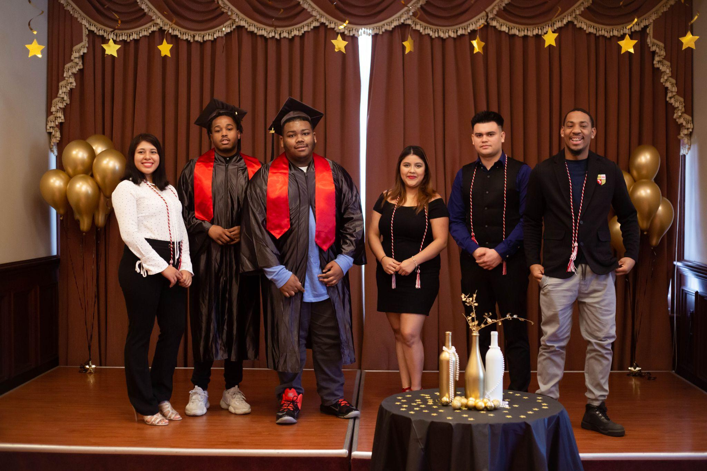

**Annual Report: 2021-2022 School Year**

**3224 16th Street NW • Washington, DC 20010**

**(202) 319-2228**

**www.laycca-org**

Board Chair: Lori Kaplan

# TABLE OF CONTENTS

**I. SCHOOL DESCRIPTION**

A. Mission Statement 3

B. School Program 3

1. Summary of Curriculum Design and Instructional Approach 3

2. Parental Involvement Efforts 4

**II.** **SCHOOL PERFORMANCE**

A. Performance and Progress 5

1. Meeting our Mission 5

2. Meeting our Goals: Academic Expectations and Outcomes 10

B. Unique Accomplishments and Recognition 11

C. List of Donors 13

**III.** **DATA REPORT 1**4

**IV.** **APPENDICES**

A. Staff Roster for 2021-22 School Year 16

B. Board Roster for 2021-22 School Year 22

C. Unaudited Year-End 2021-22 Financial Statement 25

D. Board-Approved 2022-23 Budget 27

# I. School Description

## Mission Statement

LAYC Career Academy Public Charter School’s (Career Academy) mission is to engage and empower young people between the ages of 16 and 24 by providing a college preparatory education, career training in high-growth occupations, and/or enrollment in college-credit classes. We envision a future in which all youth have a successful pathway to college and careers with opportunities for advancement, and where all youth can become engaged members of the community.

## School Program

## Summary of Curriculum Design and Instructional Approach

Career Academy is an innovative public charter school that engages and empowers economically-disenfranchised youth of color by providing them with literacy skills, a college preparatory curriculum, college-credit classes, a high school diploma/GED, and career preparation in the high-growth health care and information technology fields. Our target population is opportunity youth, or youth who have become disconnected from both work and school.

Career Academy’s goal is to help students achieve their college and career objectives through a challenging and relevant curriculum and intensive, individualized wrap-around services and supports that address obstacles that might otherwise derail their progress. Career Academy serves approximately 100 students each year and 95% of our students are working or enrolled in college within six months of graduation.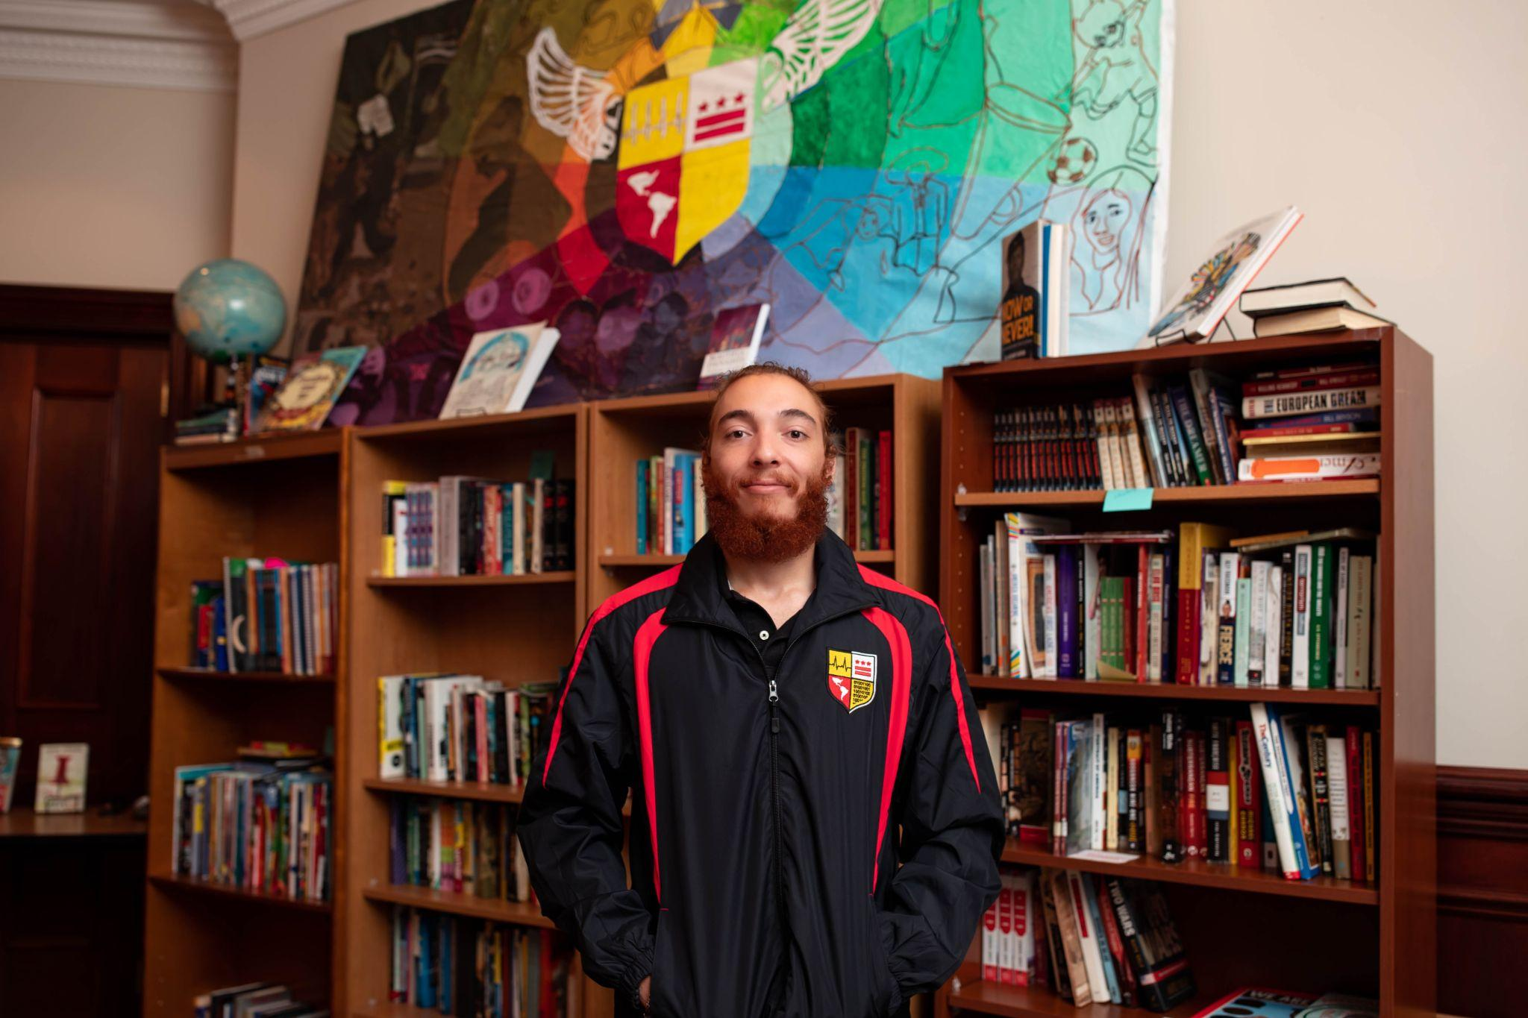

After a decade in operation, Career Academy has a strong reputation among opportunity youth and their advocates for helping students who face extraordinary challenges make academic gains, secure high school credentials and college credits, and develop the skills needed for success in high-growth career sectors. Our goal from our founding has been for every student to exit the school fully prepared for a career and/or college, a goal that remains the same today. To graduate, students are expected to earn a high school diploma, demonstrate an 11th grade reading level, and gain a Microsoft Office Suite certification or an Internet Computing & Core Certification. Students also complete coursework in one of the school’s specialized pathways: Medical Assistant (MA), Information Technology (IT), or College Pathway.

Our educational program is highly flexible and personalized, meeting students where they are and enabling them to progress at the pace that works best for them. We offer part-time and full-time enrollments, as well as in-person and virtual class options. Career Academy students are older than their peers in traditional high schools, and they are anxious to meet their goals as quickly as possible. At the same time, they often need to balance school with conflicting demands on their time, such as employment, care-giving for a family member, or trying to meet basic needs. Using an evidence-based, personalized learning model, Career Academy administrators, faculty, and staff tailor individual schedules to meet each student’s needs, using classroom lessons, one-on-one instruction, and online learning tools to support achievement and keep students engaged and motivated. Crucially, we offer all of our programming at no cost to students, meaning all our students graduate debt-free and ready for a sustaining professional career and/or college. 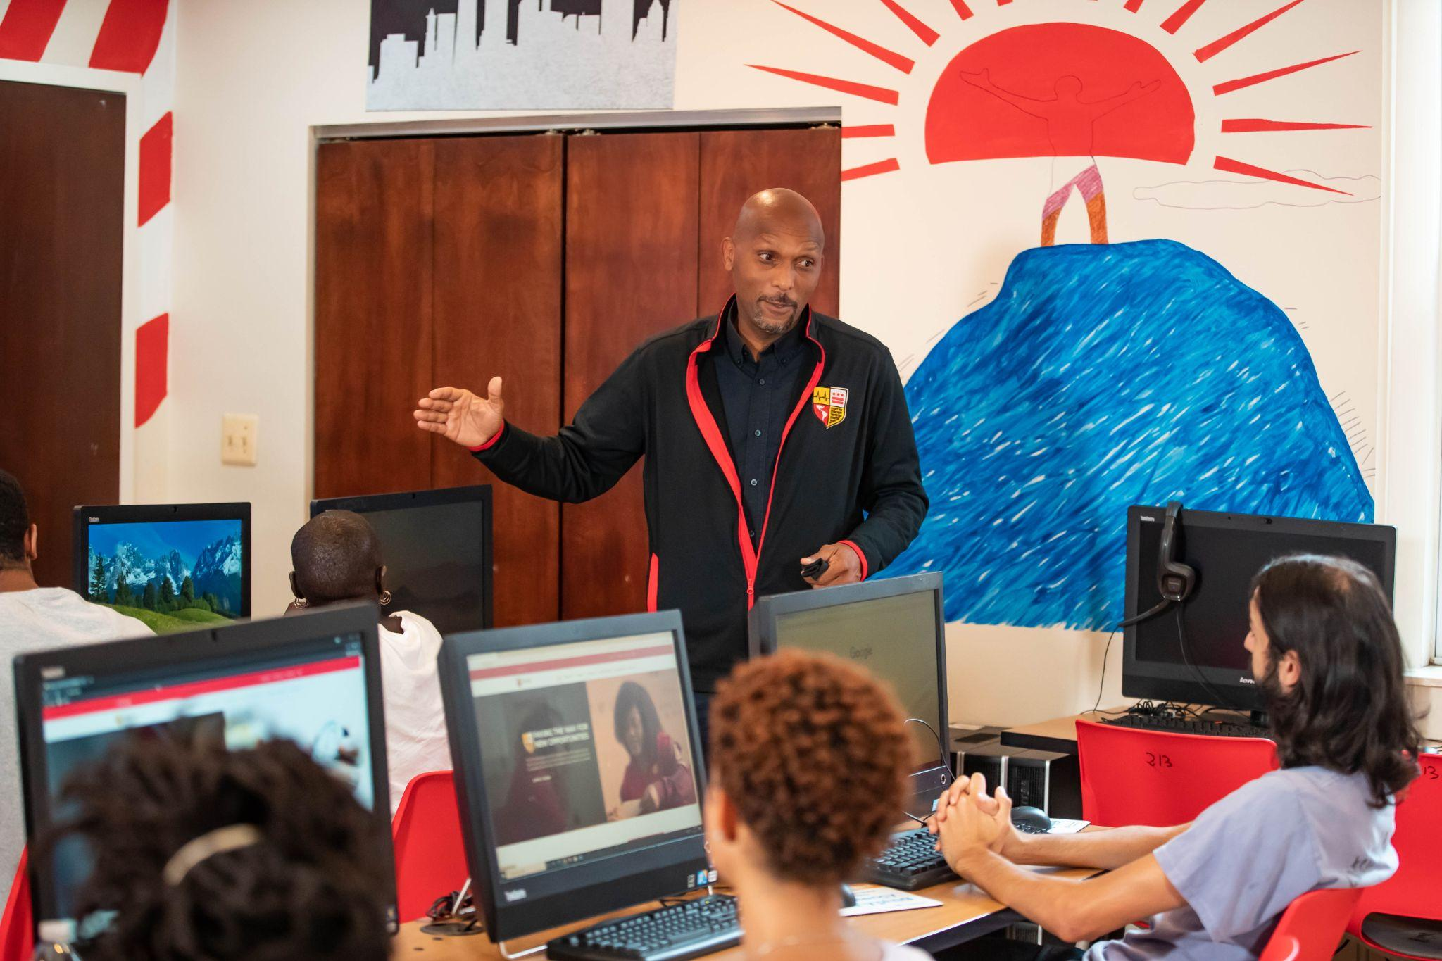

School faculty and staff are also committed to building community and are intentional in creating and sustaining a school environment in which students feel safe and valued.

Career Academy students are supported by a team of student support specialists (also known as S3s), who are adviser-advocates helping youth with non-academic issues as basic as the need for clothing and shelter, and as complex as parenting or caring for an elderly relative. Our College and Career Access Department provides comprehensive professional development and works one-on-one with students to ensure that they will be successful in higher education, work, or both. All Career Academy staff have been trained in restorative practices and use those principles to build community in and out of the classroom.

## Parental Involvement Efforts

Many Career Academy students have little to no educational support in their home environment. Some students have strained or adversarial relationships with their parents, if the parents are still in the students’ lives. Additionally, 90% of our students in the 2021-22 school year (SY) were over 18, and many live on their own or are parenting themselves. Despite these challenges, Career Academy staff encourage all students to involve their family in their educational growth as is possible and appropriate to their situations. During the enrollment process, for example, students are invited to bring a family member or other supportive adult to join the orientation session and provide additional background information on the student’s educational and personal history.

A core Career Academy belief is that all students need at least one supportive adult in their lives, so teachers, administrators, student support staff, and college and career access staff encourage and support students in their efforts to cultivate positive relationships with family members and/or other caring adults. In particular, student support specialists work with students on these relationships by helping them process any trauma they have from prior negative relationships, giving them tools to repair those relationships when possible, and/or identifying other adults who can provide support. These essential staff members also conduct home visits and invite family members and other adults who play positive roles in our students’ lives to school events and activities, in an effort to forge stronger school-family relationships wherever possible.

**II. School Performance**

## Performance and Progress

## Meeting our Mission

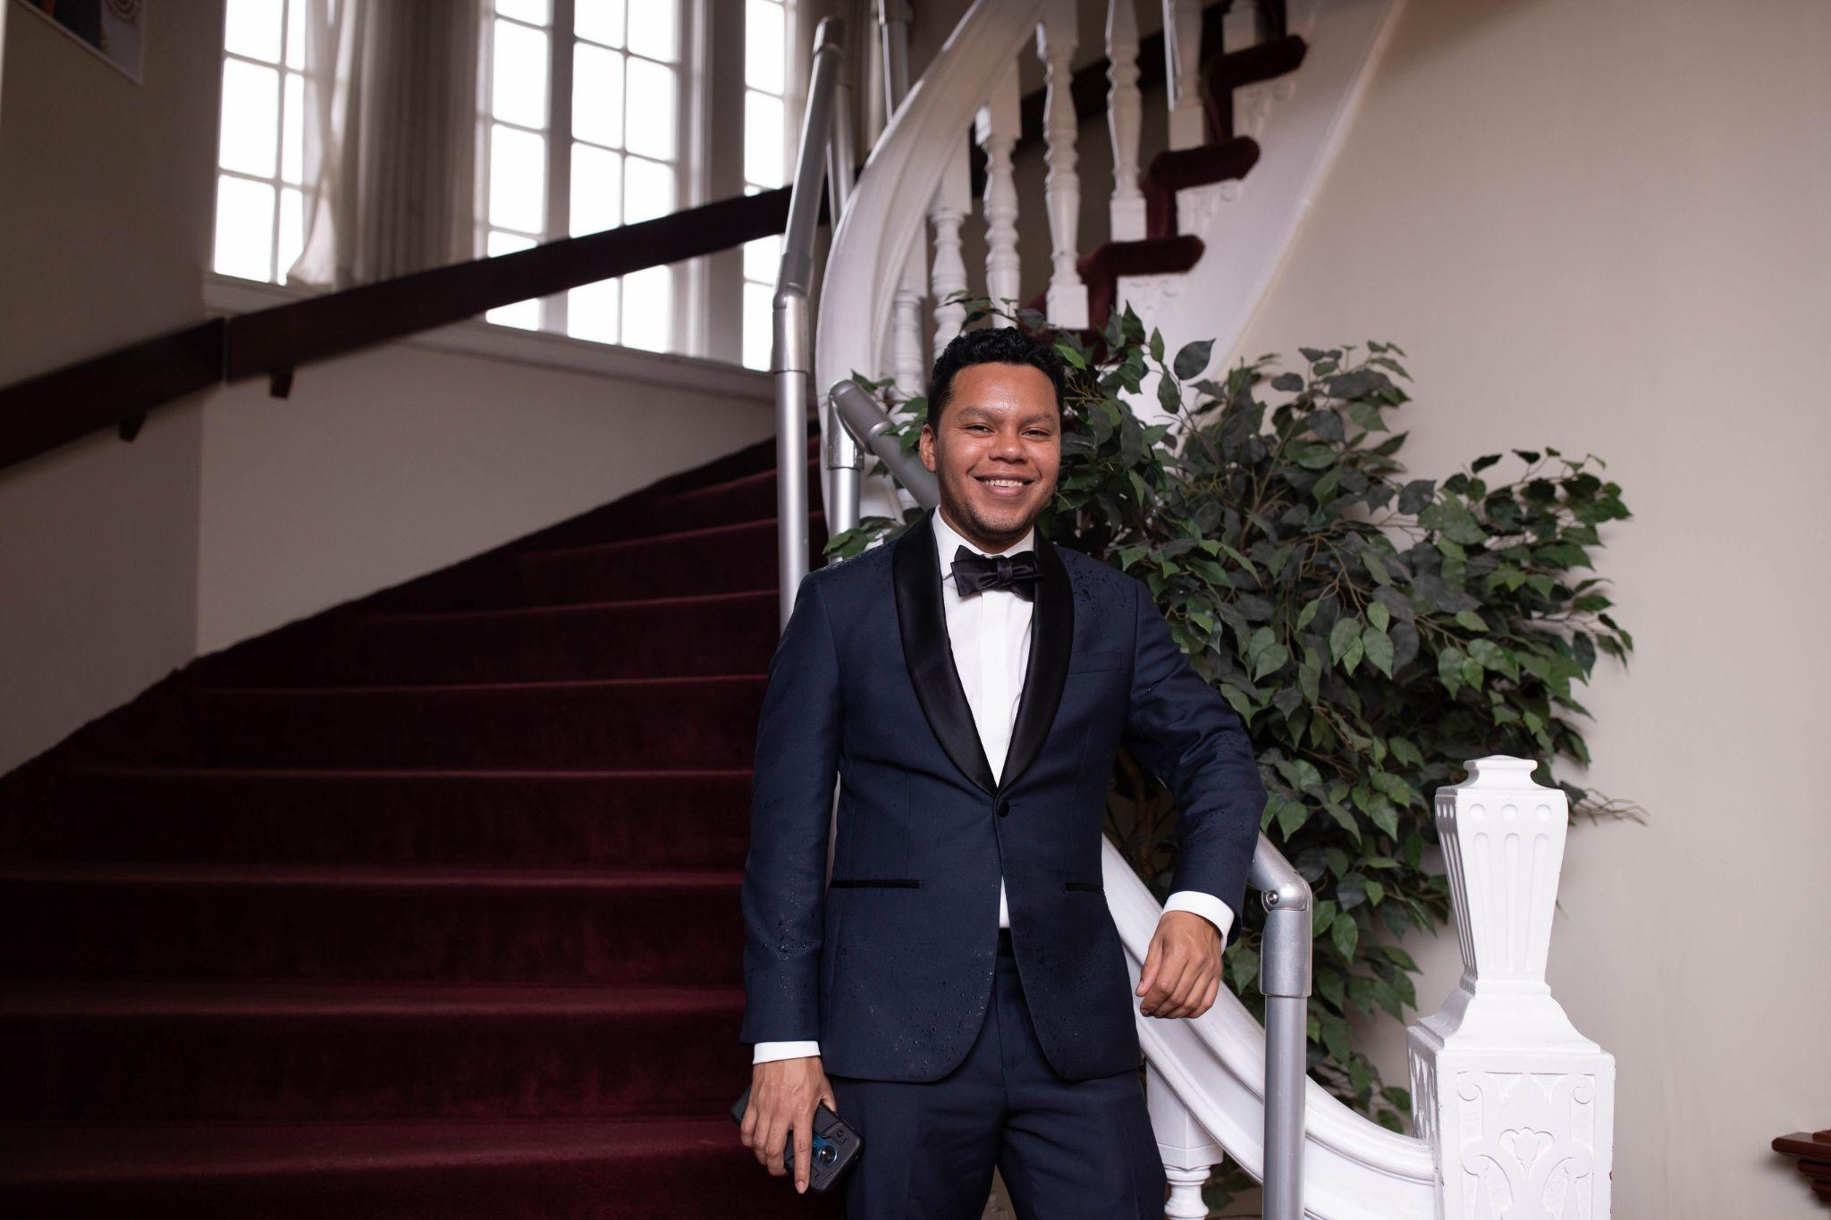

Career Academy meets its mission by providing every student with high-quality and accessible academic and occupational programming, non-academic supports essential to success, and college and career preparation. Career Academy enables youth to make significant educational gains while also increasing their confidence; developing critical soft skills; gaining work experience and college credits; and/or securing marketable IT and health care-related credentials.

We pride ourselves on being an inclusive organization dedicated to serving all youth who are in need of our services, regardless of circumstances. Career Academy enrolls youth who have dropped out of a D.C. public or public charter school, youth who earned a diploma but left high school without being truly prepared for college or work, and immigrant youth, primarily from Central or South America or Africa, who are seeking safety and educational opportunities in the U.S. These youth are at a high risk of unemployment or a lifetime working in dead-end jobs. At Career Academy, they benefit from an affirming and inclusive environment that offers job training and educational programs. We also value and support diversity through culturally sensitive programming.

Career Academy’s audited enrollment in SY22 was 94 students. Of that, 52% identified as African American, 46% as Hispanic/LatinX, and two percent as Other. Sixty-two percent identified as female and 38% as male. Our students came from all eight DC Wards, with 50% residing in Wards 1 and 4 and 29% in Wards 7 and 8. One in five students experienced homelessness at some point during the school year, one in five were differently abled with special needs, one in ten were pregnant or parenting, and nearly all students qualified for free and reduced meals.

In the classroom, Career Academy students have varying needs and goals. Some students come with high school credentials, others wish to earn a GED, and still others want to learn English language skills. Some students want to explore college-level courses, while others are primarily attracted to the MA and IT Pathways. To meet all of these different needs, Career Academy offers students literacy and numeracy classes, a college preparatory education, career training in high-growth occupations, and the opportunity to take college-credit classes. Our model is built on competency-based graduation and promotion requirements, and our curriculum is designed to ensure college and career readiness. Our innovative and personalized design has produced strong student outcomes: 95% of our graduates are working or enrolled in college within six months of graduation. 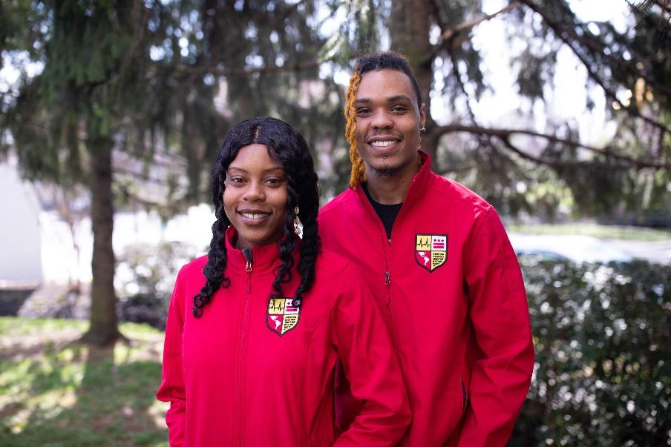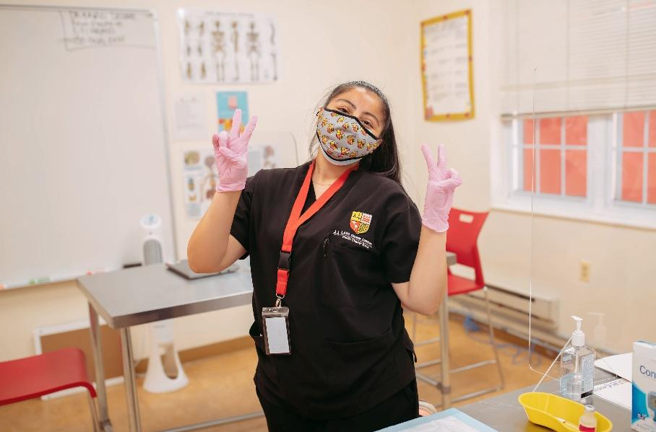

There remains a high need for education and training among DC opportunity youth. According to the DC ReEngagement Center, there are over 8,000 opportunity youth between the ages of 16 and 24 that need reconnection options to help them get back on track to reach their goals. And while other DC programs offer learners occupation-specific job skills, most serve adults; opportunity youth need programs that are targeted to their age and developmental level. Career Academy students have the chance to receive a college preparatory education, GED attainment and basic skills courses, and industry-specific career training. Our full academic curriculum and students’ day-to-day activities are as follows:

The academic year consists of three trimesters, each of which is divided into two sessions of approximately six weeks. Each trimester, students take the CASAS exam in reading and math to assess progress (for returning students) and determine course placements (for new and returning students). Students are placed in courses that align with their levels: for example, students who need support acquiring English language skills are placed in an English Language Learner (ELL) cohort until they earn a score of 228 in listening and 236 in reading on the CASAS exam; students seeking a GED are placed into our GED cohort until they pass the exam.

Based on these assessment results, instructors will decide how to level their courses to best align with student needs. Instructors integrate technology into the curriculum to provide more tailored lessons and assignments for each student. They also connect the curriculum to the health care and IT sectors, as well as students’ other interests in order to make the subject matter more engaging. Instruction is provided in small groups, and teachers collaborate across subject areas, often team-teaching or coordinating lesson plans for a more dynamic and contextualized presentation.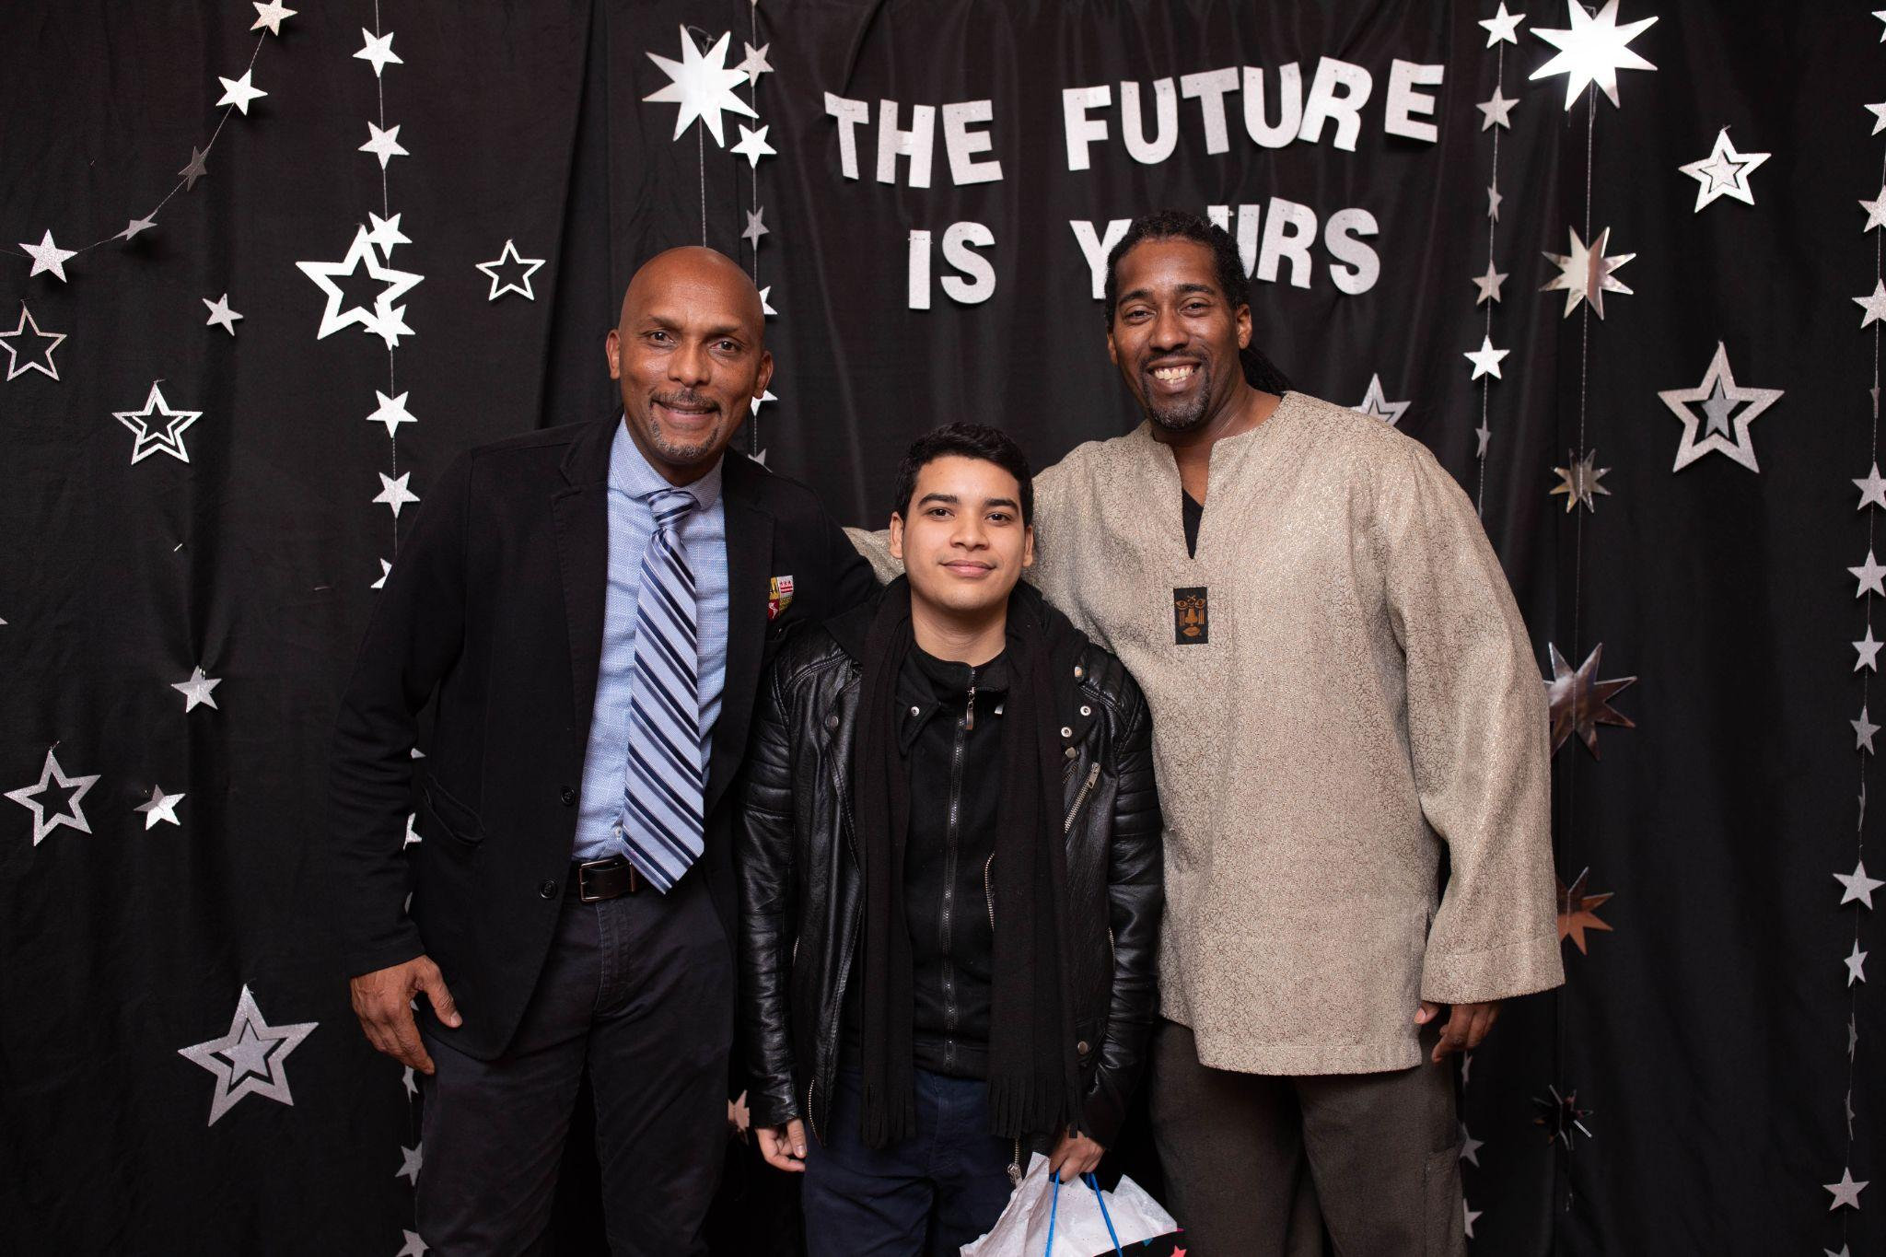

**General Education Programs:**

*High School Diploma/GED Program and ELL Classes:*

On average, approximately half of our students enter Career Academy seeking a high school diploma or, for immigrant students, stronger English language skills. GED students take English, math, social studies, and science classes. English Language Learners focus on strengthening their reading, writing, and speaking skills. Eighty seven percent of ELL students and 68% of students overall increased their reading and math skills by two grade levels or more in SY22.

*Literacy and Numeracy Classes:*

In recent years, Career Academy staff have seen a large increase in the number of students enrolling in the school that do not have the literacy and numeracy skills needed to succeed in higher education or a long-term career, causing them to remain in low-wage jobs and/or pay for expensive remedial classes in college. This is indicative of a nation-wide problem: according to 2018 data from The Brookings Institution, a total of 5.3 million youth across the US have graduated high school and are working, but do not have the skills or training to move beyond minimum-wage jobs. In SY22, 66% of students entering Career Academy with a high school diploma and 100% of those entering without one had reading or math levels at a middle school level or lower. Recognizing this and other evolving needs of our students, we have made changes to the format of our general education program. In the past, students were required to be reading and performing math on an 11th grade level before they could officially enter one of the three pathways. Now, any student with a high school diploma can start their training classes while also working to strengthen their basic skills.

These students’ schedules reflect a blend of classes that is tailored to their specific needs: students take a blend of classes designed to build their literacy and numeracy skills and career training or college preparatory classes from one of the pathways. This new practice has helped students move through our programs faster by making course materials more relevant to their career goals and increasing student motivation. The amount of time a student spends in their general education varies, depending on their skill level at enrollment, and the pace of their progress.

Nationwide, students are dropping out of high school or graduating without the necessary skills to succeed in college or sustaining careers. Career Academy is an important part of a broader effort to make sure all children are prepared for college and careers, with efforts starting in public preschools and continuing through K-12 education. 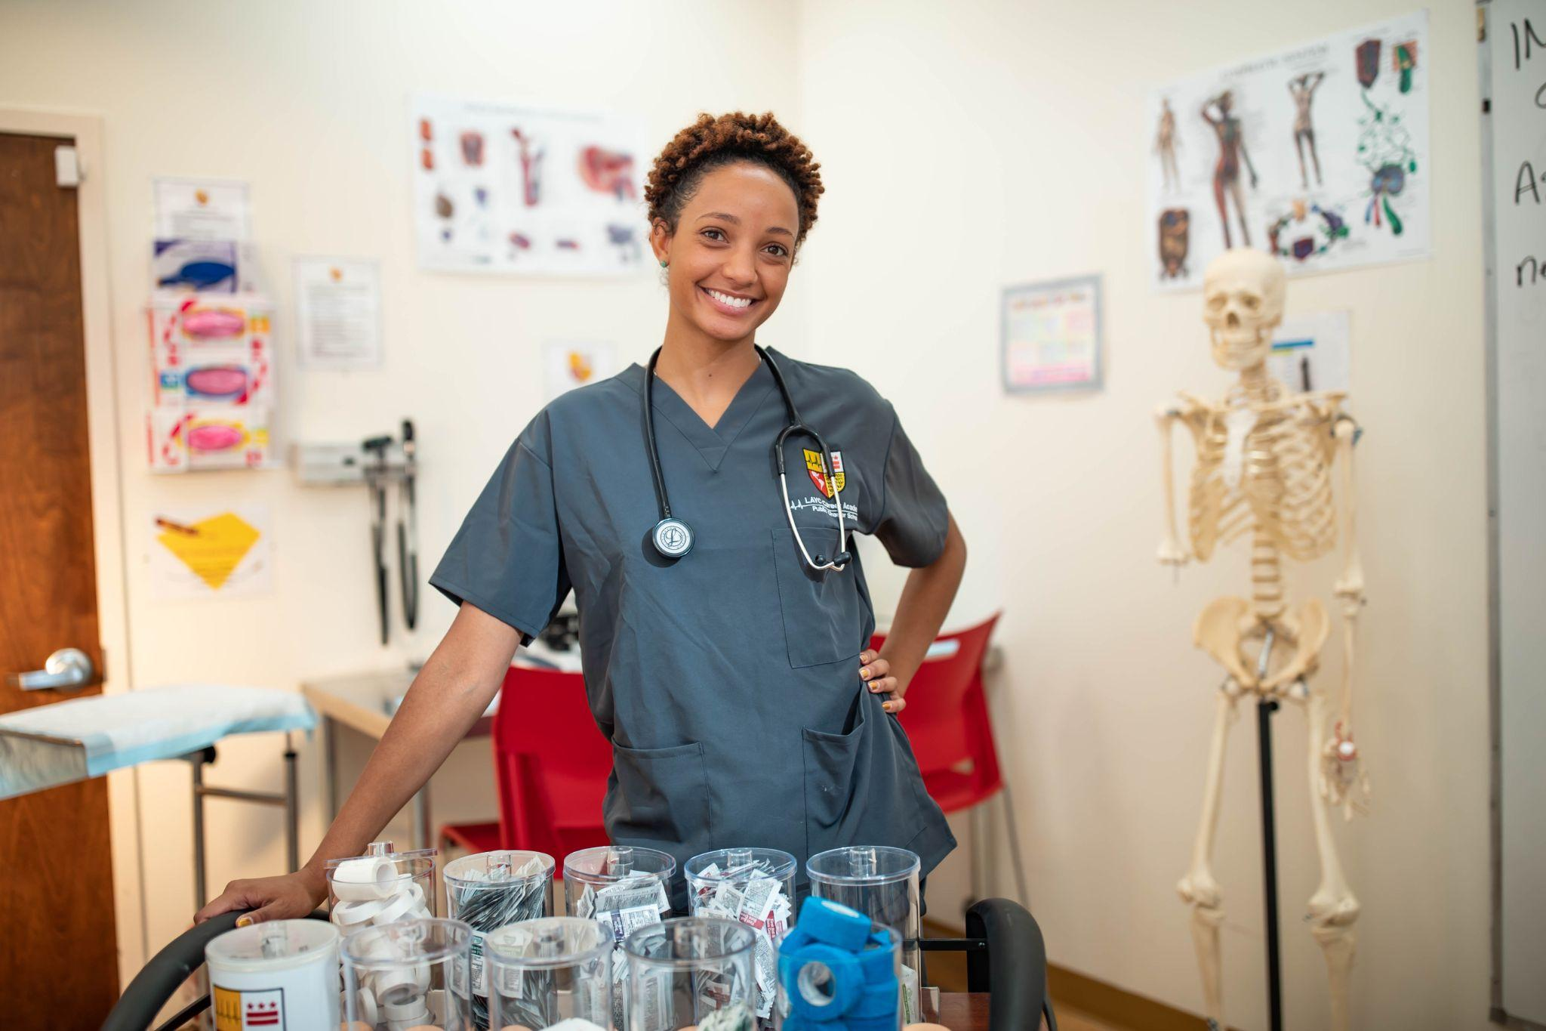

## Pathway Programs:

## *The MA Pathway:*

## In preparation for work as medical assistants, students learn to provide direct services to patients (e.g., how to obtain vital signs, administer an EKG, and perform spirometry and venipuncture). They master autoclave techniques, become CPR- and AED-certified, and develop basic billing and coding skills. Students then spend their final trimester in an internship at a local healthcare organization, with hosts like A Plus Medical Center, Community of Hope, Mary’s Center, and Whitman-Walker Health. Students who complete this pathway graduate as Certified Clinical Medical Assistants.

## *The IT Pathway:*

IT Pathway students learn to install, configure, maintain, and troubleshoot networking hardware, software, and peripheral components of computers and operating systems, including Microsoft Windows. Students graduate with the skills to find successful careers as IT help desk specialists, one of the fastest growing occupations in the region. Like students in the MA Pathway, IT students also complete an internship, giving them the tools to function in a professional environment. IT students are required to pass the IC3 and A+ exams in order to graduate and many elect to earn the Microsoft, Network+, and Security+ certifications as well.Two people looking at a computer

## *The College Pathway:*

Early exposure to college-level classes helps students gain confidence and experience that will enable them to navigate a college campus and complete college-level coursework more effectively. College and Career Access Department staff help College Pathway students research departments and programs within colleges and universities, arrange individual college visits and group tours, help students apply for financial aid, develop course schedules, and take dual enrollment classes through a partnership with the University of the District of Columbia. To exit from the College Pathway, students must earn at least six college credits.

To assist our students in reaching their academic and career goals, Career Academy offers a robust continuum of support services that are designed to help students navigate challenges associated with housing stability, food insecurity, caregiving and parenting, mental health, and more. Finally, up to and after graduation, students and alumni receive help with job placement and other transition services.

## 2. Meeting our Goals and Academic Achievement Expectations

| Goal | Description | Met or Unmet? |
| --- | --- | --- |
| AE PMF as Goals (prior to Policy) | For SY 2021-22 and beyond, LAYC Career Academy Public Charter School will achieve a weighted range score of 65.0% on at least three out of the four Adult Education PMF indicators with no indicator having a weighted range score below 45.0%.  For school years, 2017-18 through 2025-26, inclusive, scores for each indicator shall be calculated in accordance with the standards outlined in the AE PMF Tech Guide for SY 2017-18 | Met |
| Mission-Specific Goal: IT Pathway CompTIA A+ | Beginning August 31, 2019:  Starting with students entering the IT Pathway in SY 2016-17, within two years of entering the pathway, 50.0% of students in the IT Pathway will earn an A + certification. | N/A n<10 |
| Mission-Specific Goal: MA Pathway CCMA Credential | Beginning August 31, 2019:  Starting with students who entered the MA Pathway in SY 2016--17, within two years of entering the pathway, 50.0% of students in the MA Pathway will earn a certified clinical medical assistant ("CCMA") credential. | N/A n<10 |
| Mission-Specific Goal: MA Pathway Internships | Beginning August 31, 2019:  Starting with students who entered the MA Pathway in SY 2016--17, within two years of entering the pathway, at least 60.0% of students in the MA Pathway will complete an internship in MA. | N/A n<10 |
| Mission-Specific: College Pathway College Credits Earned | Beginning August 31, 2019:  Starting with students who entered the College Pathway in SY 2016-17, within two years of entering the pathway, at least 60.0% of students in the College Pathway will earn at least three college credits. | N/A n<10 |
| Mission-Specific: Data & Testing Practices | Beginning in 2018:  The school will adhere to the following data and testing practices:  a. The school will pre-test every student who meets the SY 2017-18 PMF Tech Guide's definition of enrolled or accept a zero for that student for each applicable measure.  b. The school will submit to DC PCSB each student's Pathway designation within 15 days of the student enrolling in the school, or within 15 days of the student changing pathways or transitioning from pre-GED to GED-candidate  c. The school will administer at least two Comprehensive Adult Student Assessment System (CASAS) subtests, one in math and one in reading, to every student.[1]  d. The school will provide DC PCSB with the student-level data needed to calculate the mission-specific goals in early September, following DC PCSB's Adult Education PMF timeline | Met |

## Unique Accomplishments and Recognition

**Ten Years!**

The 2021-22 school year marks Career Academy’s ten year anniversary, which included a successful ten year review by the DC Public Charter School Board.

**Tier I Achievements**

In a year where student attendance and persistence were historically low in schools, Career Academy earned the highest scores in its history, earning a Tier I for these measures in our charter goals. We also achieved a Tier 1 designation in Math and Reading progress as well as career and college placement and retention measures. The school missed the all- around Tier I rating by a single math GED test this year.

**US Secretary of Labor Martin Walsh visits LAYC Career Academy**

On October 14, 2021, Secretary Walsh spent close to two hours touring Career Academy and speaking to students. He told his own story including how he stopped drinking, went back to college and ultimately became the Mayor of Boston. He also asked about our students’ stories, quickly realizing they were often similar to his own. Students asked him a wide range of questions, including his stance on immigration reform, what he is doing to protect workers, and what advice he has for students. Secretary Walsh also spoke about his strong support for immigrant rights and how he stood up to people who threatened immigrants by saying, “I don’t tolerate bullies.” Finally, he shared the ways that the Department of Labor was working to make jobs that Career Academy students have in construction and the restaurant industry safer.

**Career Academy students wins Bronze at the Microsoft National Championship**

Bria-Amani Adams, a Career Academy IT student, has won third place for the entire country in Microsoft Word at the Microsoft National Championship. Ms. Adams sealed her win by getting the third highest score on the Microsoft Word test during that competition that took place in Dallas, Texas in June 2022. Ms. Adams and fellow students Michael Fernandez and Jeffrey Ampedu were all named DC Microsoft Champions and obtained scores that were high enough to qualify for competing on the national level. We are so proud of these students for all of their accomplishments!

**Community Leadership**

Career Academy staff have continued to be recognized and take on leadership roles in the District. Corey Carroll earned the Education Excellence Award from One World and was chosen to be part of OSSE's 2022 Superintendent's Teacher Advisory Team. Jacqueline Fernandez-Romero served as a member of the OSSE Principal Advisory Committee. Nicole Hanrahan served as a board member of the DC Workforce Investment Council and was one of nine charter leaders elected to the Executive Committee of DC Charter Alliance. Ms. Hanrahan’s advocacy work was also recognized in a [Washington Post article](https://www.washingtonpost.com/education/2022/04/09/dc-schools-at-risk-kids/?eType=EmailBlastContent&eId=aa16d6b6-c1f6-4671-8201-905c0f0de59f) in April.

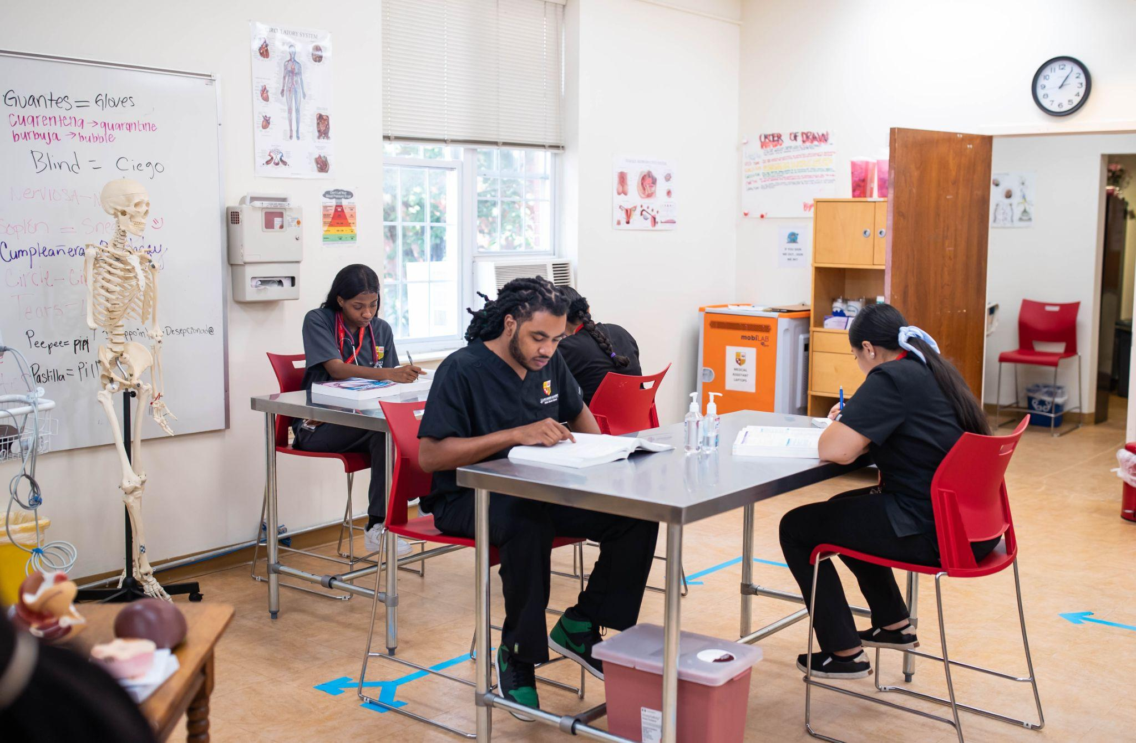

**The Power of Partnerships**

Career Academy has built several fruitful partnerships with neighboring organizations, including one with American University (AU) through their Center for Community Engagement and Service. Under this partnership, AU students provide the school with legal assistance, tutors, mentorship opportunities, and financial literacy and technology support. In the spring of 2022, AU students ran information sessions on immigrants rights and helped ten Career Academy students develop a job search portfolio that included a cover letter, resume, and personal statement. Currently, AU students are running a financial literacy workshop, with sessions focusing on student debt, budget management, home ownership, and more.

Latin American Youth Center also reinstated its community schools program with Career Academy and YouthBuild Public Charter School this year. Through this program, Latin American Youth Center provides mental health, food, diaper, and healthcare and career related programming for students at both LAYC Career Academy and YouthBuild.

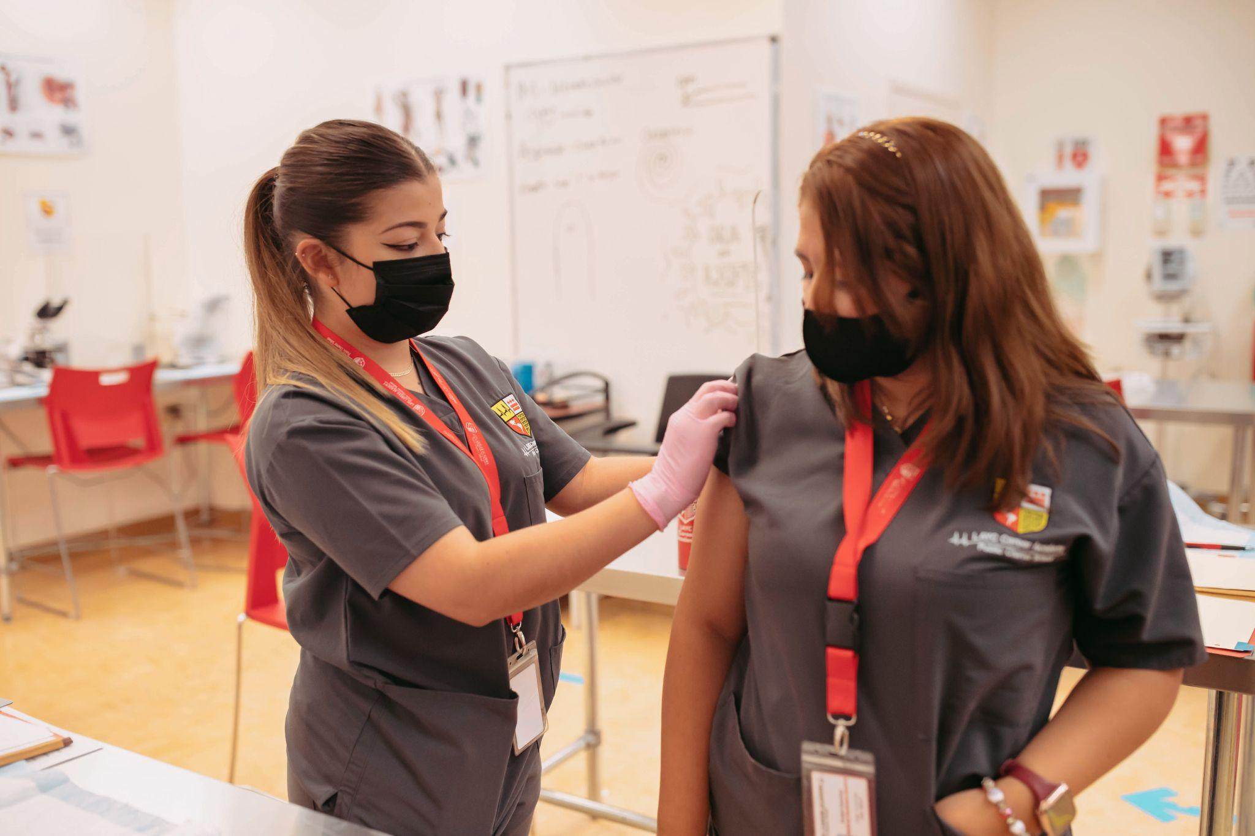

**Managing the COVID-19 Pandemic with Strength**

Finally, Career Academy is very proud of the work that the school did to effectively manage the pandemic this school year. Despite the fact that the school fully reopened for full time, in-person learning in SY22, there was no community spread at all; the school only had four cases total from August 2021 until the BA2 variant emerged in May. The school attributes its success to a high level of community investment in safety coupled with strict masking, social distancing and strong cleaning protocols.

**C. List of Donors (at the level of $500 or higher)**

*Blair Hewes*

*Daivd A. Gould*

*D’Angelo Family Charitable Fund*

*Dina Halme*

*Elizabeth Burrell*

*From Me to You*

*Greater Washington Community Foundation*

*Kevin Smith*

*Lori Kaplan Charitable Fund*

*Nicole Hanrahan*

*Richard E. and Nancy P. Marriott Foundation*

*Sunrise Foundation*

*The Benevity Community Impact Fund*

*Tonia Wellons*

*United Way of National Capital Area*

# 

# School Year 2021-2022 Data Report

**General Information**

| **Source** | **Data Point** |
| --- | --- |
| PCSB | LEA Name: LAYC Career Academy PCS |
| PCSB | Campus Name: LAYC Career Academy PCS |
| PCSB | Grades served: Adult |
| PCSB | Overall Audited Enrollment: 94 |

**Enrollment by grade level according to OSSE’s Audited Enrollment Report**

| **Grade** | **PK3** | **PK4** | **KG** | **1** | **2** | **3** | **4** | **5** | **6** |
| --- | --- | --- | --- | --- | --- | --- | --- | --- | --- |
| **Student Count** | 0 | 0 | 0 | 0 | 0 | 0 | 0 | 0 | 0 |
| **Grade** | **7** | **8** | **9** | **10** | **11** | **12** | **Alternative** | **Adult** | **SPED\*** |
| **Student Count** | 0 | 0 | 0 | 0 | 0 | 0 | 0 | 94 | 0 |

*Note: This field is only filled in for St. Coletta Special Education PCS as it is the only charter LEA that exclusively serves students with disabilities.

**Student Data Points**

| School | **Total number of instructional days:** 198 |
| --- | --- |
| PCSB | **Suspension Rate:**0% |
| PCSB | **Expulsion Rate:**0.00% |
| PCSB | **Instructional Time Lost to Discipline:**0.00% |
| PCSB | **In-Seat Attendance:**62.50%* |
| PCSB | **Average Daily Attendance:** The SRA requires annual reports to include a school’s average daily membership.  To meet this requirement, PCSB will provide following verified data points: (1) audited enrollment;  (2) mid-year withdrawals; and (3) mid-year entries. **(No action necessary.)** |
| PCSB | **Midyear Withdrawals (MYW):**57.40% (54 students) |
| PCSB | **Midyear Entries (MYE):**48.90% (46 students) |
| PCSB | **Promotion Rate (LEA):**Not Applicable |
| PCSB  (SY20-21) | **Graduation Rates:**Not Applicable |
| School  (SY20-21) | **College Acceptance Rates:** Not Applicable |
| School  (SY20-21) | **College Admission Test Scores:**Not Applicable |

**Teacher and Admin Data Points**

| School | **Teacher Attrition Rate:** 22% |
| --- | --- |
| School | **Number of Teachers:** 10  “Teacher” is defined as any adult responsible for the instruction of students at least 50% of the time, including, but not limited to, lead teachers, teacher residents, special education teachers, and teacher fellows. |
| School | **Teacher Salary**  1.   Average: $59,641  2.   Range -- Minimum: $46,350 Maximum: $91,087 |
| School | **Executive Compensation**  Salaries (including bonuses) of the five most highly-compensated individuals in the organization, if over $100,000, for SY21-22.  The salaries for the principal and executive director are $131,808 and $117,877, respectively. |

*Notes:

* The provided in-seat attendance rates align to the in-seat attendance rates available in OSSE’s SY21-22 Charter Sector Attendance Qlik application as of August 2022. However, the validated rates that schools will confirm with OSSE during Metric Calculation Confirmation this fall may vary slightly. • Unvalidated MYW and MYE rates are provided based on examining student movement between 10/6 and 5/31 in SY 2021-22, attempting to mimic the DC School Report Card business rules as closely as possible. However, the validated student mobility rates that schools will confirm with OSSE during Metric Calculation Confirmation this fall may vary slightly.

**Disclaimer:** Career Academy acknowledges that DC PCSB’s review and publication of this annual report does not imply concurrence or disagreement with the content herein.

# Appendices

## APPENDIX A. Staff Roster for the 2021-22 School Year

## LEADERSHIP AND ADMINISTRATION STAFF

**Executive Director:** Nicole Hanrahan

Ms. Hanrahan leads the senior team that manages the school’s day-to-day operations and supports the board of directors as it guides the school’s overall direction, sets policy, and monitors school performance. Prior to her current role, she was Latin American Youth Center’s (LAYC) chief strategy officer, supporting its efforts to grow and deepen its impact for youth in Washington, DC. Before joining LAYC, she served as a director at Community Wealth Ventures, where she helped nonprofits and foundations build capacity and improve sustainability. Prior to that, she directed workforce development programs in New York, Chicago, and Boston. Ms. Hanrahan is a member of Leadership Greater Washington and holds a bachelor’s in public policy from Brown University and master’s in business administration from the Harvard Business School.

**Principal:** Jacqueline Fernandez-Romero

A prominent educator, scientist, and community activist, Dr. Fernandez-Romero taught science at Career Academy for several years and served as its interim principal starting in summer 2017 through April 2018. She became principal in May 2018. She has received honors and awards for her scientific research, community involvement, and mentorship of minority students in the science, technology, engineering, and math (STEM) fields. Prior to joining Career Academy, she worked in the Space Biosciences Division at NASA’s Ames Research Center as a Microbiologist and as a teacher at schools in DC and New York. Dr. Fernandez-Romero obtained a bachelor’s in La Raza studies and a bachelor’s in Microbiology from San Francisco State University, and she earned a master’s of education from Lesley University. In 2017, she completed her doctorate in curriculum and instruction with a concentration in STEM education from Texas Tech’s University Global PRISE (Pragmatic Researchers in STEM Education) Program.

**Director of Operations and Communications:** Bernadette Kreh

Ms. Kreh is a DC area local who calls Silver Spring, Maryland home. She is a first generation American of Filipino descent. Ms. Kreh attended Towson University where she majored in communication studies. After spending nearly a decade away from the DC area, she returned home in search of a more fulfilling career, despite being on track for a leadership role in corporate America. She found her sense of fulfillment at Career Academy, where she started as a special education paraprofessional. Eager to make a difference at the school, she quickly ascended to academic support coordinator and later assumed the role of marketing manager. Ms. Kreh was tasked with managing the school’s accreditation process through the Middle States Association. After over a year of hard work and dedication, she successfully led the school to its very first accreditation. Shortly after this accomplishment, Ms. Kreh was promoted to director of operations and communications.

**Recruitment Specialist**: Steven Blanco

Mr. Blanco was raised in Hyattsville, Maryland. After high school, Mr. Blanco enrolled in a nursing assistant program and, upon graduating, he was quickly promoted to the nursing staff coordinator within six months. After working in multiple five-star skilled nursing facilities for seven years, he decided that he wanted to explore another passion. Mr. Blanco worked as a mentor to Hyattsville youth in his role as a football and wrestling coach in Prince George's County. During this time, he realized that education and mentorship aligned more with his core values. Mr. Blanco got his start in education in 2016 after completing the resident teacher program in Prince George’s County. After serving as the head football and wrestling coach in Prince George's County for eight years, he decided to step down and pursue a career in digital marketing. In 2018 he joined the Career Academy team as a recruitment specialist and is a member of the marketing team.

**Board Liaison/Registrar:** Ashley Datcher

Ms. Datcher  is originally from the Takoma Park/Silver Spring, MD area. After she attended Bennett College in Greensboro, NC, she found her passion working with opportunity youth. For over ten years, Ms. Datcher served youth of different ages as a job coach with LAYC’s Maryland Multicultural Youth Center in Silver Spring, MD. She taught Job Readiness Training courses at Montgomery College and enrolled and supervised participants and companies for the Summer Youth Job program. As an academic advisor for college-bound students, Ms. Datcher supported participants of the Upward Bound program. Ms. Datcher was a founding member of Career Academy and has served in the role as registrar from the school’s beginning.

## ACADEMIC PROGRAM STAFF

**Director of Academics**: Ivette Cruz

Ms. Cruz is a 25-year veteran educator who began her career in K-12 schools. Ms. Cruz decided to continue growing professionally by entering the field of adult education and bilingualism. She became academic director of Ana G. Mendez University System, where she provided leadership on all academic programs while guiding the implementation of the Discipline-Based Dual-Language Immersion Model. After almost four years in this position, Ms. Cruz decided to join Career Academy as the director of academics to continue helping underserved students in their efforts to pursue a GED or career. Ms. Cruz has a bachelor’s in child development from the University of Puerto Rico and a master’s in educational leadership from the University of Phoenix. She is currently studying for her doctorate in education with a specialization in Educational Leadership in Adult Education. She is a former member of Maryland’s Teaching English to Speakers of Other Languages (TESOL) board, where she was the editor of the newsletter. She was also part of DC OSSE’s 2019 Title III Advisory Committee, a group of stakeholders from different schools that offer their insights on policies and regulations in the area of English Language Learners. She also participated in the first Mentoring and Induction Program Development Professional Learning Community at OSSE in 2020.

**ELL Support Specialist:** Ariel Berroa

Mr. Berroa was born in Santo Domingo, Dominican Republic, came to the US at the age of 19, and quickly learned English and earned his GED. He was an AmeriCorps volunteer from 2013-2015, working with middle school students, facilitating health education workshops, coaching a soccer team, and providing ELL support. During this time, he found his passion for working with youth and using his own experience to encourage them to find their education and career paths. At Career Academy, he assists ELL students in language acquisition and enjoys working with immigrant populations.

**Reading, Writing, Social Studies, and GED Instructor**: Corey Carroll

Corey Carroll, a native of Tulsa, Oklahoma, serves as Career Academy’s writing, social studies, and GED instructor. Mr. Carroll graduated from Grambling State University where he earned a bachelor’s in political science and mass communications. After working on Capitol Hill, analyzing education policy surrounding underserved youth and social justice issues, he became an educator and academy coordinator for Prince George’s County Public Schools. Mr. Carroll has earned a dual master’s from American University in educational leadership and educational policy. In his spare time, Corey remains an active member of Kappa Alpha Psi Fraternity Inc. and works diligently as a community advocate for marginalized students throughout Prince George’s County and the District of Columbia.

**Academic Support Coordinator/Data Manager:** Erin Tarpley

Ms. Tarpley has spent much of her life living abroad. After returning to the United States, Ms. Tarpley has been involved in education in many forms, including as an assistant, a camp-counselor, a mentor, an instructor, an administrator, or a director.  She graduated from the University of Maryland, Baltimore County with a bachelor’s in history and a certification to teach secondary education in the social sciences. Ms. Tarpley later went on to earn a master’s from the University of Maryland in human resources management with a focus in adult training and learning. Before joining Career Academy, she served in student support at Walden University, taught social sciences in Baltimore City Public Schools, and headed the Arts Education department for underserved students in the Brooklyn Park area.

**Academic Support Coordinator:** Nicolas Matheus

Mr. Matheus was born in Maryland and is the first generation American born to two immigrant parents from Venezuela and Italy. He graduated with an associate’s degree from Montgomery College and then earned a bachelor’s in English focused on communication and technology from University of Maryland, Baltimore County. Mr. Matheus has worked in different parts of DC and Maryland for the past eight years. Before officially starting at Career Academy, Mr. Matheus spent two years substituting and contracting for the school, where he instructed Math classes using a personalized learning plan for students. He also created his own lesson plans for elective classes such as journalism, film and literature, and poetry. Mr. Matheus has taught science, math, and grammar/composition, assisted students with his knowledge in each area and aided ELL students with his knowledge of the Spanish language. Additionally, Mr. Matheus has spent time working with students on reaching educational and career goals by helping them apply to internships, jobs, and colleges.

**ELL Instructor:** Leslie Douglas

Mx. Douglas began working at Career Academy in August 2019. A native of Pittsburgh, Pennsylvania, she graduated with a bachelor’s degree from the University of Pittsburgh and a master’s degree from the University of the District of Columbia. An enthusiast about community building, she  has worked and volunteered around the DC Metro area since 2015. She believes that education, social interconnection, and equity are the tools needed to foster a brighter future.

**Math Instructor:** Alain Carbajal

Alain Carbajal began working with Career Academy in November 2020. Born and raised in Peru, he came to the U.S. at the age of 10. He grew up in Fairfax, VA and got a scholarship to Virginia Commonwealth University. In college, he started studying mechanical engineering, but switched to applied mathematics with a minor in statistics because of the love for the subject. Throughout high school and college, Mr. Carbajal was always passionate about teaching mathematics and would always find time to tutor whoever needed the help. Upon graduating in 2017, Mr. Carbajal started teaching at a private school in College Park, MD and then went into teaching at private schools in Annandale VA. He has taught the advanced/honors classes for math for grades ranging from 3rd to 12th grade. Mr. Carbajal is a dedicated teacher who follows the teaching philosophy that “grades are secondary, but knowledge and understanding comes first.”

**Medical Assistant Program Director/Instructor:**Brian Sevier

Dr. Brian Sevier, a DC area native, has spent the last 21 years serving the medical community. His medical career began while serving in the U.S. Army, with the 160th SOAR Night Stalkers, as a Special Operations Paramedic. While on his second tour in Afghanistan, Dr. Sevier received his master’s degree in health care administration from Baylor University Health Science Center. After an exemplary and highly decorated military career, Dr. Sevier left the army for a life in the private sector. He first taught didactic courses to nursing students at Vanderbilt University and then moved on to become the first Black safety and environmental director at Trinity Industries, the world’s largest makers of inland barges. After a short stint, Dr. Sevier returned to his roots and became the Director of Medical Education of Radiation Oncology at Georgetown University Hospital. During his tenure, he received his Doctorate of Health Administration from Johns Hopkins University. Since obtaining his degree, Dr. Sevier has helped write health care policy for six US senators and has served the last two presidents as a health care policy analyst. Finally landing at Career Academy, he has been instrumental in revitalizing the medical assisting program.

**Information Technology Program Coordinator/Instructor**: Abner Soto-Henry

In total, Mr. Soto-Henry has more than 24 years of experience in education. Originally from Costa Rica, Abner speaks fluent Spanish, English, and Portuguese, enabling him to connect with the students he serves. He has received numerous notable awards throughout his teaching career.  Mr. Soto-Henry started his career in 1995 as a technology education instructor at the Workforce Development Center (Centro de Formación y Capacitación Portuaria) in Costa Rica, after graduating from Universidad Interamericana de Costa Rica in San José.  Mr. Soto-Henry teaches information technology education at Career Academy, specializing in Microsoft certifications, IC3 Digital Literacy certifications, and CompTIA certifications. A former professional soccer player, his passion for teaching is only rivaled by his love of the game.

**Director of College and Career Access:** Erica Lloyd

In her role as Director of College and Career Access, Ms. Lloyd is passionate about helping Career Academy students prepare to make the transition to college and/or the career they wish to pursue. Ms. Lloyd came to the Career Academy with a Bachelors of History and a Masters in Teaching from the University of Virginia, as well as over twenty years of experience in the nonprofit sector. She first served as the Program Director of a youth development program in Charlottesville, mentoring over 60 youth from the third grade through their transition to college. She then moved to Port-au-Prince to work as the Research Director of a composting program in Haiti. In 2019 Ms. Lloyd returned to the DC area, where she was born and raised, and joined the Career Academy in 2022.

**SPECIAL EDUCATION DEPARTMENT**

**Special Education Services Instructor/Coordinator:** Martha Sanchez

Ms. Sanchez attended The George Washington University and earned a master's degree in curriculum and instruction with a concentration in English as a Second Language and Bilingual Special Education. Ms. Sanchez joined Career Academy in August 2018 and is now going into her fourth year with the school. She started her career in education working with DC Public Schools as a special education teacher. Since then, she has worked in the field of special education as a teacher, as a transition counselor and as a consultant for several charter schools in the DC area.

## 

## Special Education Paraprofessional: Ericka Rivera Ms. Rivera is an experienced educator of 15+ years.  She began her teaching career by working part-time as a kindergarten teacher’s assistant while she was in college. She soon discovered that her passion was teaching and within a year she shifted career paths and became an early childhood educator.  She earned her associate’s in child development. And in 2017 she won the “*Excellence in Care and Education*” award from her company, chosen out of more than 15,000 teachers.  She came to Career Academy in December 2020 with a great desire to bring her experience and skill set into helping Special Education students.  She is currently in the process of earning a degree in social sciences with a specialization in special education.

## STUDENT SUPPORT TEAM

**Director of Student Support:** Dedria Harrod

Ms. Harrod began working with Career Academy in September 2018. Over the past 25 years, Ms. Harrod has worked with several agencies, including education, corrections, mental health, and housing, that have assisted youth with special needs in the Greater DC area, Illinois, and Indiana. Ms. Harrod began her career working with special needs children in Prince George’s County, MD as a behavior/crisis intervention specialist. She then moved to the Midwest and worked with the Regional Office of Education as a safe & drug coordinator, school guidance counselor and finally a juvenile correctional facility therapist. Since returning to the DC area in 2007, Ms. Harrod has worked as a school guidance counselor, youth services program director for a housing agency and as a student support specialist. Ms. Harrod holds a master’s of science in community psychology and a bachelor’s of science degree in Psychology.

**Student Support Specialist**: N’Kosi Ayize

Mr. Ayize is a third-generation Washingtonian who was Career Academy’s fitness professional for three years before assuming the post of a student support specialist. He has extensive background in youth programs, supports, and services, and enjoys the benefits of being a certified personal trainer, martial arts master/instructor, productivity specialist, and avid origami artist. He truly works to personify the Capoeira philosophy of "facing confrontation with a smile."

**Student Support Specialist:** Cristal Flores

Ms. Flores is a first-generation Salvadoran-American, born and raised in New Jersey. Ms. Flores graduated from Rutgers University with a bachelor’s in psychology and criminal justice, and joined the Career Academy team in February 2020. Over the course of her career, Ms. Flores has worked in a plethora of settings such as nonprofit organizations, public safety divisions, a center for adult autism services, and educational institutions. Ms. Flores has extensive experience in the field of victimology as she worked directly with crime victims prior to joining Career Academy; she has educated thousands of individuals through theater improvisational skits on domestic violence, sexual assault, sexual harassment, bullying, and language while using a bystander- intervention model. In efforts to expand her understanding of multicultural humility, Ms. Flores also participated in an Alternative Spring Break trip to the Dominican Republic. During this Alternative Spring Break, Ms. Flores explored themes of racism, sexism, sexual orientation, immigration, and much more.

**Student Support Specialist:** Monica Santos

Ms. Santos is a first generation Honduran-American, born in Virginia and raised in Prince George’s County. Ms. Santos graduated from the University of Maryland, College Park with a bachelor’s in Anthropology and Sociology. Upon graduation, she began working at a residential facility providing support to undocumented youth. She joined the school team in October 2020 eager to be a support system for our students and assist them throughout their journey at Career Academy. Ms. Santos is passionate about helping others, especially children and families, as well as learning about different cultures.

## 

## APPENDIX B. Board Roster for the 2021-22 School Year

Please note that an even number (10) of board members is listed below because one board member joined and another resigned over the course of the school year. The school ended the year with nine trustees.

**Kate Brannon, Treasurer** (2014 – present)

**DC Resident: Yes**

Ms. Brannon is the director of finance at the George Washington University Graduate School of Education and Human Development. She provides leadership and strategic direction related to the development of the University’s budget. Her expertise includes budget development, strategic planning, forecasting, establishing internal controls, and overall financial oversight. Before joining Georgetown University, Ms. Brannon worked at The George Washington University for more than 15 years. Ms. Brannon holds a bachelor’s degree in accounting from Elon University and a master’s of business administration from the George Washington University.

**Elizabeth Burrell**

**DC Resident: Yes**

Ms. Burrell is Board Co-Chair of the Latin American Youth Center. Previously, she has served as an administrator for secondary education in high schools in New York and Maryland. Ms. Burrell holds a B.A. from Anna Maria College and an MS in Education Policy and Administration from State University of New York in Albany.

**Emmanuel Caudillo, Board Member** (2015 – present)

**DC Resident: Yes**

Mr. Caudillo works for the US Department of Education and is a special advisor to the White House Initiative on Educational Excellence for Hispanics. In this role, he oversees the operational duties of the initiative, outreach to Hispanic-serving institutions, and youth engagement activities. Previously, he was a policy analyst at the U.S. Department of Education from 2009 to 2012. He has also held research positions at Abt Associates and the National Council on Teacher Quality. Mr. Caudillo holds a bachelor’s degree from the University of Southern California and a master’s in public policy from The George Washington University.

**Dean D’Angelo**

**DC Resident: No**

Mr. D’Angelo is a founding partner of Stellus Capital Management and runs the firm’s Private Credit strategy and serves on its investment committee. He has over 30 years of experience in investment banking and principal investing. Prior to forming Stellus, Mr. D’Angelo was a director in the Direct Capital Group at the D. E. Shaw group, a global investment and technology development firm and was a principal of Allied Capital Corporation, a publicly-traded business development company, where he focused on making debt and equity investments in middle-market companies. Mr. D’Angelo received his B.B.A. in accounting from The College of William and Mary, his M.A. in international economics and relations from The Paul H. Nitze School of Advanced International Studies at The Johns Hopkins University, and his M.B.A., with a concentration in finance, from the Wharton School of the University of Pennsylvania.

**Ana Hageage, Vice Chair** (2018 – present)

**DC Resident: Yes**

Ms. Hageage currently serves in the Biden-Harris Administration as the Chief of Staff for the Employment and Training Administration in the U.S. Department of Labor. Prior to her appointment, she served as the deputy lead for the Community College Growth Engine Fund, turning community colleges into bridges to dignified work for every American learner and worker, starting with almost 6,000 learners in six communities. Throughout her career, Ana has developed a deep expertise in workforce development at the local, regional, and national levels supporting economic mobility for underserved workers. She has led national initiatives aimed at scaling industry partnerships and sector strategies and served as a policy advisor to the U.S. Department of Labor under the Obama Administration. Ana also has expertise in youth policy and advocacy and has worked on the ground to deliver adult basic education, job readiness training, sector-focused certifications, employment and wrap-around services to opportunity youth. Ana holds a degree in cultural anthropology from the University of Maryland and resides in Washington, D.C. with her husband and two sons.

**Lori Kaplan, Chair** (2012 – present)

## DC Resident: Yes

Ms. Kaplan retired as president & chief executive officer of LAYC in June 2018 after leading the organization for 30 years. Ms. Kaplan is continuing her involvement with LAYC as special projects advisor to support the leadership transition. In addition, Ms. Kaplan was the original executive director of the Next Step Public Charter School (PCS), which she founded in 1996, and a major force in the development of YouthBuild PCS and LAYC Bilingual Montessori PCS. She also serves on the board of Youth Radio, an award-winning media production company that trains diverse young people in digital media and technology.

**Linda Moore, Secretary** (2017 – present)

## DC Resident: Yes

Ms. Moore is the founder of the Elsie Whitlow Stokes Community Freedom PCS, which opened in 1998 with 35 students in a rented space in a church basement in Ward 1. Today, the school owns its building in Ward 5 and serves 350 students in grades PK3 to 6. It became a Tier 1 school in 2012 and operates with a bilingual education model, with at least half of each students’ education conducted in French or Spanish. Ms. Moore has served on the DC Charter School Association board of directors and as the chairperson of the DC Special Education Cooperative. She was inducted into the National Alliance for Public Charter Schools' Hall of Fame in 2013.

**Juan Carlos Pereira, Board Member** (2019 – present)

**DC Resident: No**

Mr. Pereira is a principal investment officer at the International Finance Corporation (IFC) where he works with private sector clients, governments, local stakeholders, and other partners to promote sustainable economic development and create economic opportunities in developing countries. Before joining IFC, he co-founded and led ProNicaragua, Nicaragua’s investment promotion and economic development agency, and worked in M&A advisory and telecommunications in the U.S. and Europe. He holds a bachelor’s in Economics from Santa Clara University and a master’s degree in business administration from Harvard Business School. He speaks Spanish, French, and Italian and is conversant in Portuguese.

**Talib Robinson, School Alumni Board Member** (2021– present)

**DC Resident: Yes**

Mr. Robinson is a graduate of the LAYC Career Academy and a current student at the University of the District of Columbia.

**Briseyda Martinez, Student Board Member** (2022 – present)

**DC Resident: Yes**

Ms. Martinez is a current medical assistant student at the LAYC Career Academy.

## 

## APPENDIX C. Unaudited Year-End 2021-22 Financial Statement

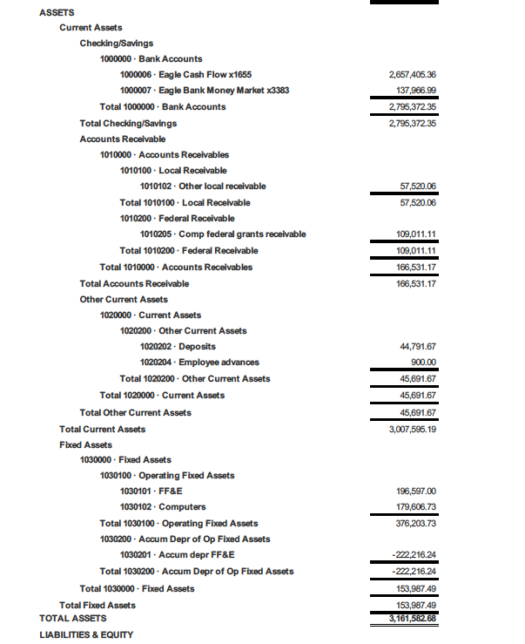

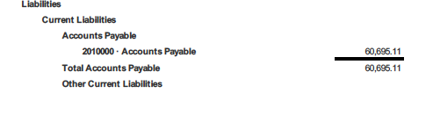

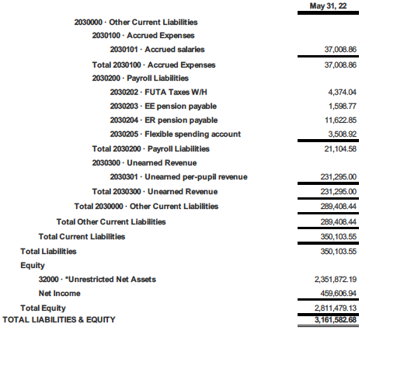

**APPENDIX D. Board-Approved 2022-23 Budget**

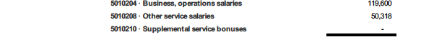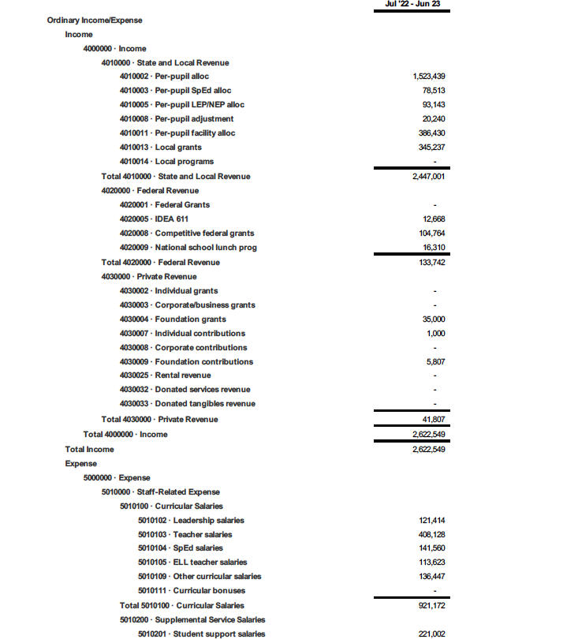

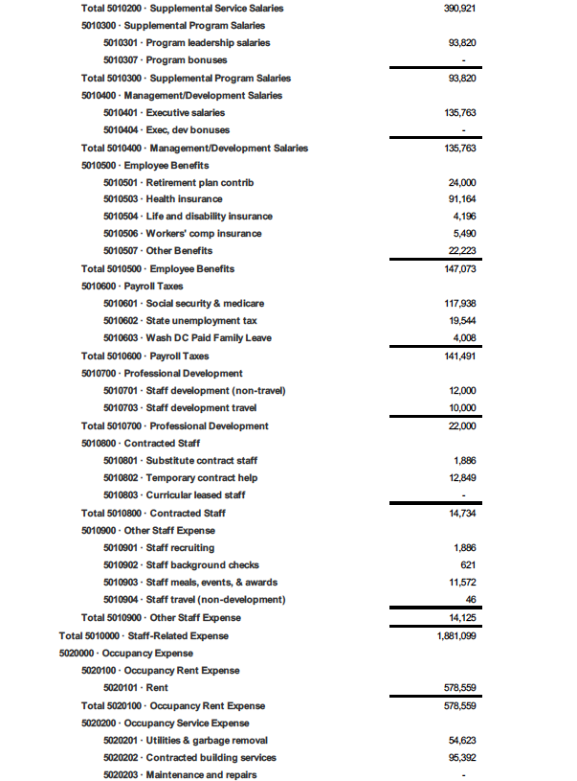



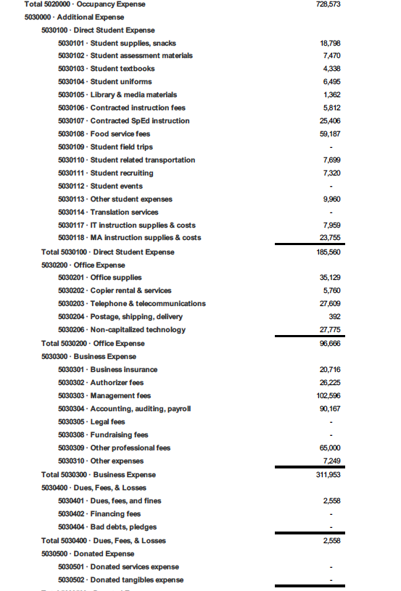

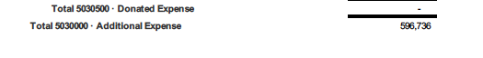

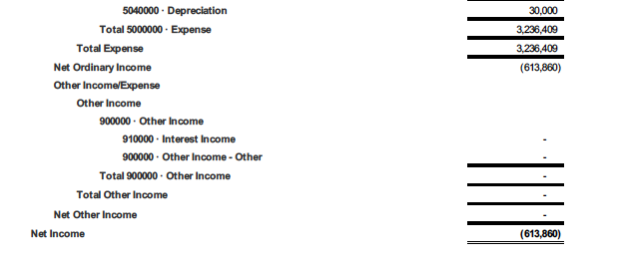

1. LAYC PCS used the Test of Adult Basic Education (TABE) throughout the review period, until September 2020, when the school adopted CASAS. For details, see Appendix 1.8, p2. Per the SY 2017 – 18 AE PMF Policy & Technical Guide, DC PCSB approves AE schools to use either assessment to measure adult students’ reading, math, and language skills.