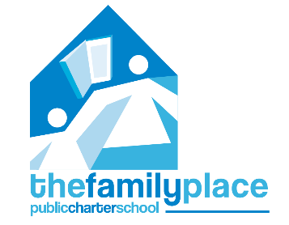

The Family Place Public Charter School
Board of Directors meeting schedule
2020-2021

August 12th, 2020
October 14th, 2020
December 9th, 2020
February 10th, 2021*
April 14th, 2021**
June 9th, 2021

The Family Place Public Charter School Board of Directors will meet on the second Wednesday of every other month (unless otherwise noted). This is no fewer than what is stated in TFPPCS’s bylaws, which require at least four meetings per year.

* The February meeting will be an open meeting.
** The 2021-2022 budget will be discussed and approved at the April meeting.

