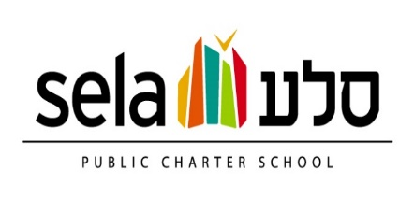
SY2020-2021 SELA Board Calendar
July 9, 2020
August 13, 2020
September 10, 2020
October 8, 2020
November 12, 2020 – OPEN TO THE PUBLIC
December 10, 2020
January 14, 2021
February 11, 2021
March 11, 2021
April 8, 2021 – OPEN TO THE PUBLIC
May 13, 2021
June 10, 2021
July 8, 2021

Assurance Statement: The number of meetings is no fewer than what is stated in Sela Public Charter School’s Bylaws. Each of the public meetings will be announced to the larger school community via the publicly available school calendar, email notification and notice through the school’s weekly announcements (Tuesday Folder).

