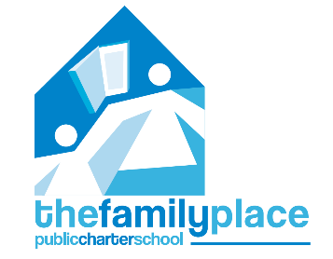

The Family Place Public Charter School
Board of Trustees meeting schedule
2021-2022

August 17th, 2021
October 19th, 2021
December 14th, 2021*
February 15th, 2022
April 19th, 2022**
June 21st, 2022

The Family Place Public Charter School Board of Trustees will meet on the third Tuesday of every other month (unless otherwise noted). This is no fewer than what is stated in TFPPCS’s bylaws, which require at least four meetings per year.

* The December meeting will be on the 2nd Tuesday.
** The 2022-2023 budget will be discussed and approved at the April meeting.

