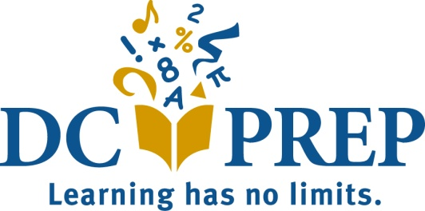

DC Prep Board of Directors’ Meeting Calendar

Meeting Dates for SY 21-22
All Board meetings will be held from 5:15 to 7:30pm.
Date Location
Tuesday, September 21, 2021 TBD
Tuesday, November 9, 2021 TBD
Tuesday, January 18, 2022 TBD
Tuesday, April 19, 2022 TBD
- We anticipate we will discuss & approve the FY22-23 budget at this meeting
Tuesday, May 17, 2022** TBD
Tuesday, June 14, 2022 TBD
**This call will be cancelled if the Budget is approved at the April Board meeting

Open Meeting Policy:
As a network of public charter schools, DC Prep embraces our responsibility to the
community of students, family and staff we serve. Board meetings are open to the
community, though personnel discussions, competitive contract negotiations, confidential
student information and sensitive matters will always be handled in closed session. Meeting
times and dates are published on DC Prep’s website, along with meeting minutes. If you are
interested in attending, please contact board.feedback@dcprep.org at least 3 business
days in advance so that we can ensure adequate space & materials for all attendees.

Assurances Statement:

This Board calendar reflects and aligns with the requirements of our bylaws.

