August
24-25 Advisor conferences
26 Student & parent orientations
27 First Day of School

Total Instructional Days: 3
Instructional Days YTD: 3

September
7 School Closed for LABOR DAY
9 MS Back to School Zoom
16 US Back to School Zoom

Total Instructional Days: 21
Instructional Days YTD: 24

October
12 School Closed: INDIGENOUS PEOPLE DAY
14 PSAT/SAT Day
30 Noon dismissal

Total Instructional Days: 21
Instructional Days YTD: 45

November
3 Noon dismissal for ELECTION DAY
11 Parent-Teacher Conferences
18 Parent-Teacher Conferences
24 Noon dismissal
25-27 School Closed for THANKSGIVING BREAK

Total Instructional Days: 18
Instructional Days YTD: 63

December
18 Noon dismissal
19-31 School Closed for WINTER BREAK

Total Instructional Days: 14
Instructional Days YTD: 77

January
1 School Closed for
WINTER BREAK
4 Classes Resume
18 MARTIN LUTHER KING, JR. DAY/
SCHOOL COMMUNITY SERVICE DAY
19 School Closed
20 School Closed for INAUGURATION DAY

Total Instructional Days: 17
Instructional Days YTD: 94

February
15 School Closed for PRESIDENTS DAY

Total Instructional Days: 19
Instructional Days YTD: 113

March
3 PSAT/SAT Day
26 Noon dismissal
27-31 School Closed for SPRING BREAK

Total Instructional Days: 20
Instructional Days YTD: 133

April
1-2 School Closed for SPRING BREAK
5 Classes Resume
16 School Closed for EMANCIPATION DAY

Total Instructional Days: 19
Instructional Days YTD: 152

May
31 School Closed for MEMORIAL DAY

Total Instructional Days: 20
Instructional Days YTD: 172

June
9 Service Day
10 MS VALEDICTION
11 US VALEDICTION
11 Final Day
14 GRADUATION
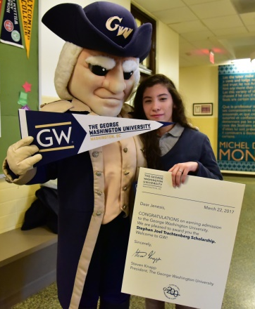
19 School Closed for JUNETEENTH

Total Instructional Days: 9
Instructional Days YTD: 181

Start time: 8:45am
End time: 4:00pm

