

**List of Required Student Enrollment Forms**

**SY 25-26**

* DC Residency Verification Form – 2025-26 School Year (OSSE Form)
* Home Visitation Consent & Verification Forms – 2025-25 School Year (OSSE Form)
* McKinney-Vento Confidential Referral Form (OSSE Form 8)
* Transcript Request Form or Transcript Waiver Form (GEC Form)
* Student Release of Information Form (GEC Form)

**Plus documents that are required to prove Residency per OSSE:**

ONE of the following:

* A Pay Stub with Current Address and DC Tax Withholding
* Supplemental Security Income Statement
* Letter that a child is a Ward of the District of Columbia
* Proof of Financial Assistance from the DC Government: TANIF or SNAP verification of income or recertification letter
* Approval letter from a housing shelter or a letter from the Housing Authority

If none of the above items are available, TWO of the following will be accepted:

* Unexpired DC Motor Vehicle Registration
* Complete, unexpired lease or rental agreement and the lease letter that reflects your proof or payment from rental office
* DC Driver’s License or Non-Driver ID
* *One utility bill* (**only** gas, electric, and water bill) with proof of payment (CR on bill or external receipt)

|  |  |  |  |  |
| --- | --- | --- | --- | --- |
| STUDENT INFORMATION | | | | |
| **Legal Last Neme:** | **Legal First Name:** | | **Legal Middle Name:** | |
| **Date of Birth:** | **Gender:**  **Male  Female** | | **Last Grade Attended:** | |
| RECORDS ARE REQUESTED FROM | | | | |
| **Name:** | | **Address:** | | |
| **City:** | | **State:** | | **Zip Code:** |
| **Phone: (Including area code)** | | **Fax Number (Including area code)** | | |
| RECORDS TO BE RELEASED | | | | |
| Mail the following records of the above-named student: * *Only checked Items will* be forwarded/released  Cumulative record including grades and attendance  Report Cards with current grade averages and academic transcript  Immunization and health/medical records  Standardized test scores  Discipline Records  Special placement records and reports (including IEP's)  Other (Specify) | | | | |
| RELEASE RECORDS TO | | | | |
| Mrs. Ashley McBarnette  Registrar Manager  1776 G Street NW, Suite #101  Washington, DC 20006  (202) 839-3676 (Office)  202-289-7365 (Fax)  Ashley.mcbarnette@goodwillexcelcenter.org | | | | |
| STUDENT SIGNATURE | | | | |
| I hereby authorize the above-named school to release any of the listed school records to the indicated school. I further authorize this receiving person or agency to release to the personnel of the school district any or all information regarding the student which pertains to his/her educational, physical, and social adjustment in school. I further understand that I may review the transfer records by making such a request to the Registrar Manager and may also have all or any part of these records properly interpreted as necessary by appropriate school personnel. | | | | |
| **Student’s Signature (*If student under 18 years of age, parent/guardian signature required*):** | | **Date:** | | |
| **Student’s Address:** | | **Student’s Phone Number:** | | |

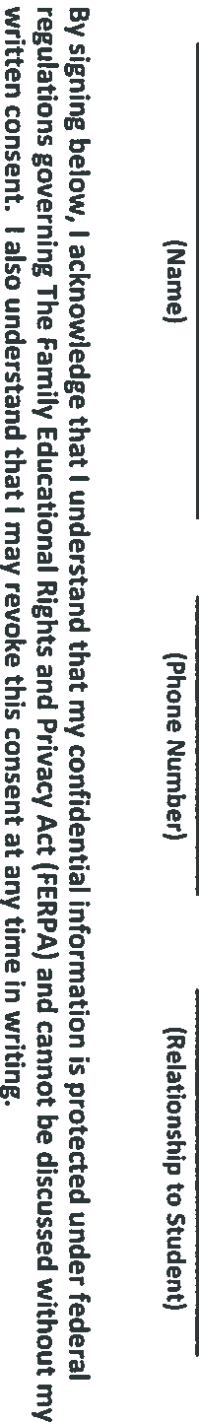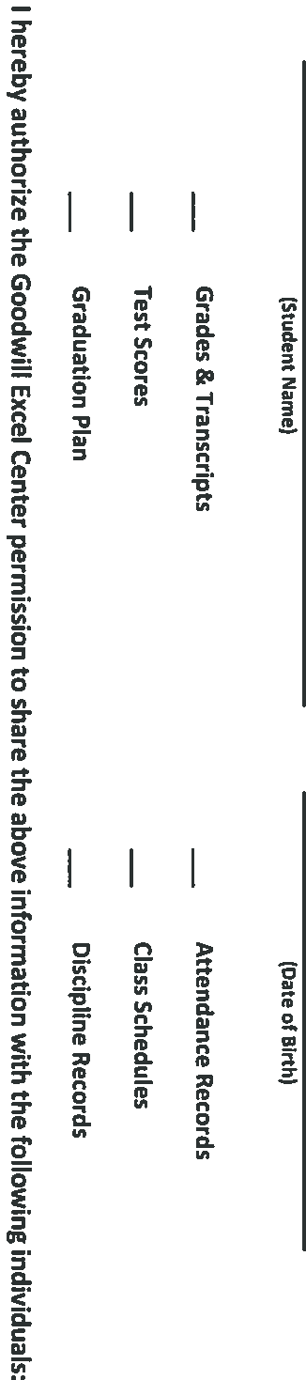

MAIL OFFICIAL TRANSCRIPT TO

ATTN: Ms. Ashley McBarnette

Registrar

1776 G Street NW, Suite #101

Washington DC 20006

ashley.mcbarnette@goodwillexcelcenter.org

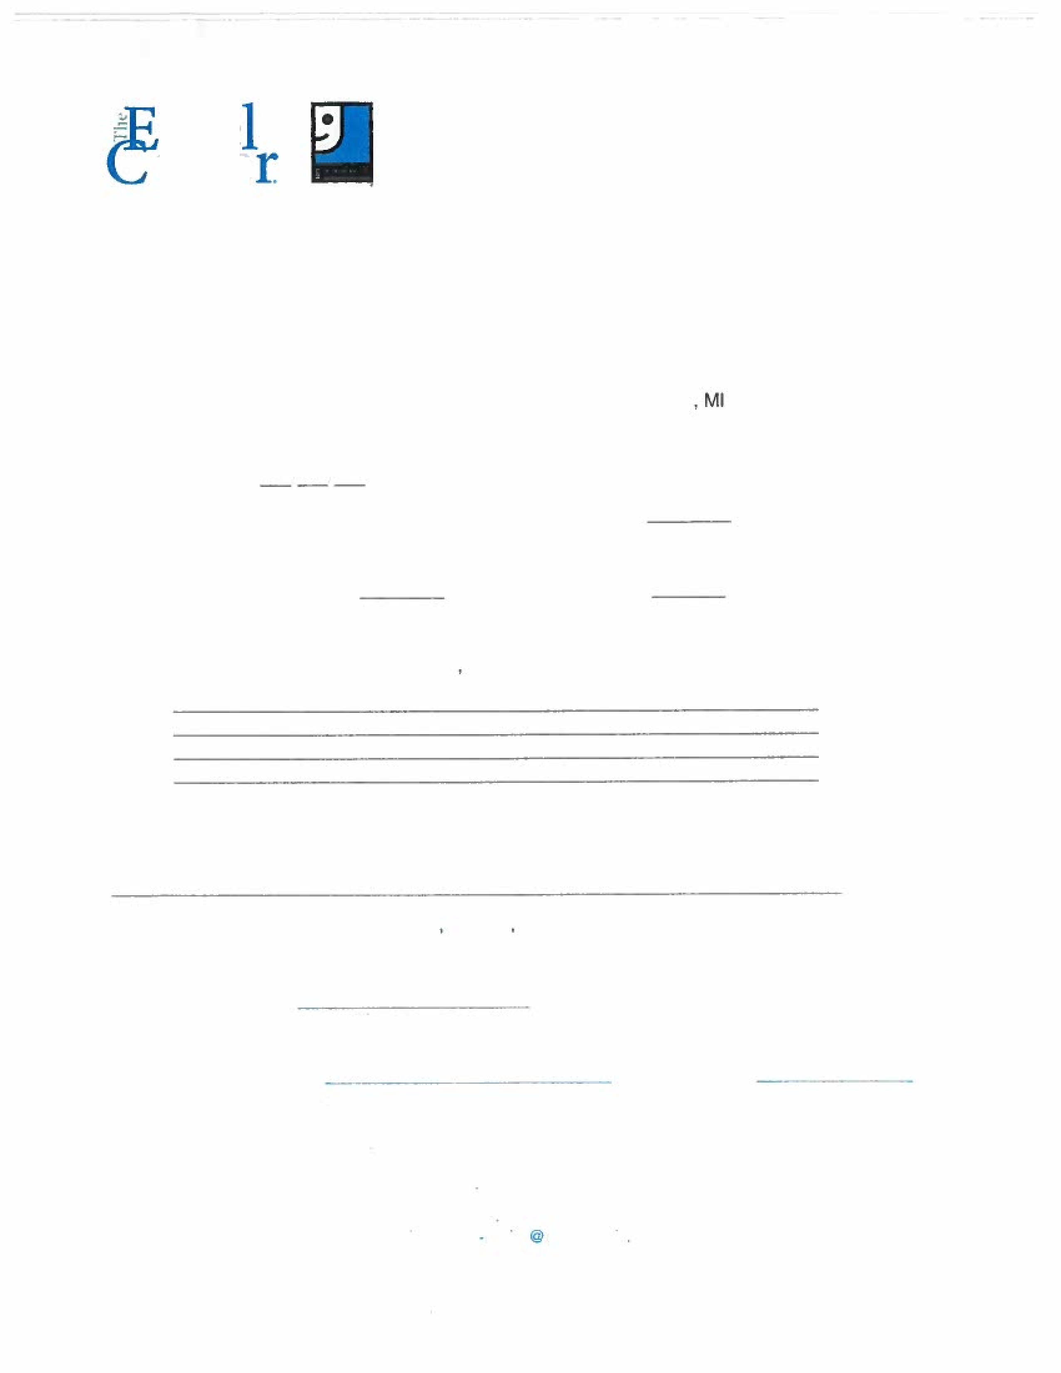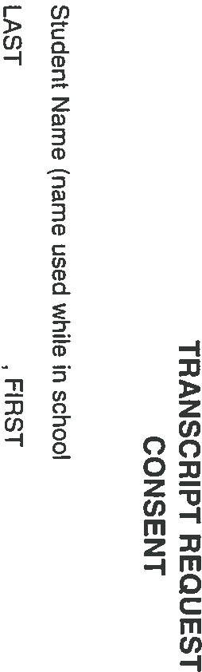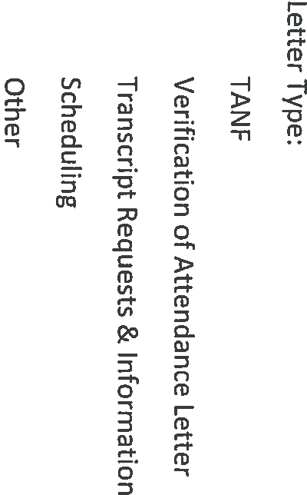

**Home Visitation Consent & Verification Form – 2024-25 School Year**

**Use this form to** consent to allowing a school official to verify District of Columbia residency by visiting your residence in-person. Complete one form per student enrolling in a DC public or public charter school.

**Step One: Provide information about your family.**

**Student First Name: Student Last Name: DOB:**

**Name of School in the 2024-25 School Year:**

**Enrolling person (see page 2) > First Name: Last Name:**

**I am the:**  student’s legal parent/guardian/custodian  student’s Other Primary Caregiver and completed the OPC Form

 adult student minor parent and completed the sworn statement

**Address of enrolling person:**

**City: State: ZIP: DC Resident:**  **Yes**  **No**

**Email: Phone:**

**Step Two: Consent to home visit by a school official.**

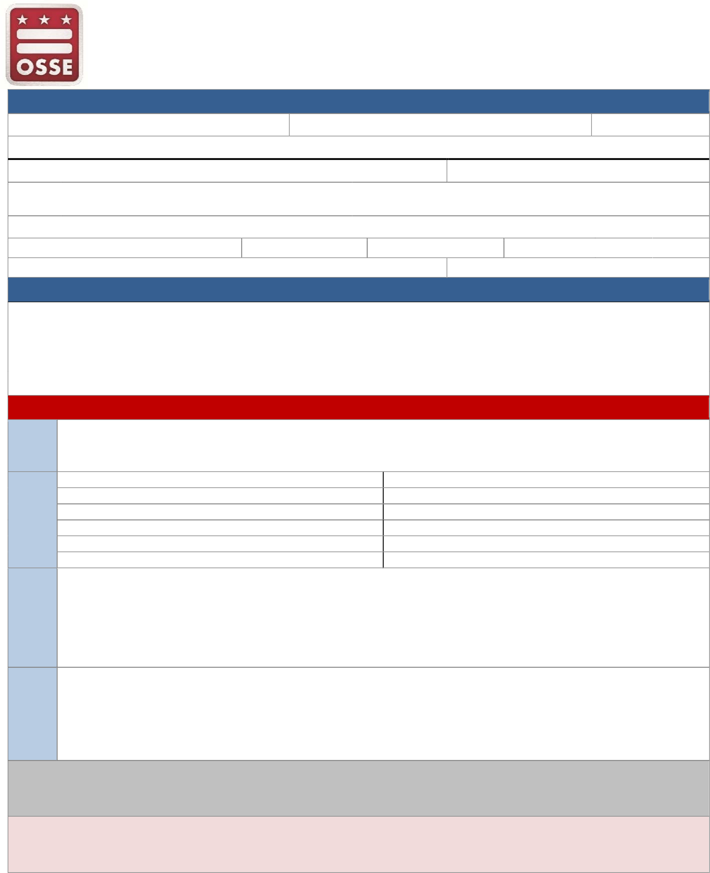I hereby consent for a school official to conduct an in-person home visit for the purpose of validating my DC residency. Personal information that may be collected in connection with this visit is to be retained in the official record of the student and will not be transferred or disclosed outside of the school, local education agency or state education agency, except where disclosure is required by law or is pursuant to the verification of my District residency. This information will be used for the purpose of validating District residency of the student’s parent, guardian, or other primary caregiver, or of the adult student him/herself.

**Signature of Person Enrolling Student**: ___________________________________________ **Date**: __________________

**SCHOOL OFFICIAL USE ONLY** The following information was verified by conducting an in-person home visit by a school official.

Step

1 **Date of in-person home visit (mm/dd/yyyy):**

**Name of people residing in the home: Relationship to student:**

Step

2

**Is there evidence that the enrolling person or Other Primary Caregiver resides at the residence? If OPC, please**

**document evidence that the *student* lives at the residence as well.**  Yes

Step **Describe:**  No

3

**Check only one:**

Step  **I have confirmed District residency of the enrolling person by conducting a home visit.**

4  **I have confirmed District residency of the enrolling person and student by conducting a home visit (OPC Only).**

* **I was unable to confirm District residency of the enrolling person by conducting a home visit**.
* **I was unable to confirm District residency of the enrolling person and student by conducting a home visit (OPC Only).**

I certify that I am the enrolling person who consented to an in-person home visit for the student named above. I attest that the information herein provided is true to the best of my knowledge based on the home visit I consented to.

**Enrolling Person Name (print)**: _______________________________ **Signature**:________________________________ **Date**: _____________

I certify that I am the school official authorized by the above named school to conduct a home visit for the student named above. I attest that the information herein provided is true to the best of my knowledge based on the home visit I conducted.

**School Official Name (print)**: _________________________________ **Signature**:________________________________ **Date**: _____________

*Office of the State Superintendent of Education* | *1050 First St. NE, Washington, DC 20002* | *202.727.6436* [| *osse.dc.gov*](https://osse.dc.gov/)  version 02.15.2023

Page **1** of **2**

# Guidance for School Official conducting home visit

|  |  |  |
| --- | --- | --- |
|  | **Reason for conducting home visit:** | **Items to confirm:** |
| OR | Residency verification of parent, guardian, custodian | * Parent, guardian, custodian has custody of student * Parent, guardian, custodian resides at the residence |
| Verification of Other Primary Caregiver (OPC) | * Evidence that the OPC resides at the residence * Evidence that the student resides at the residence |

|  |
| --- |
| ***Possible* items to look for when confirming residence** |
| The following items *could* be used to confirm the person enrolling the student and/or the student resides at the residence. **This is not an exhaustive list.**   * Personal hygiene products/toiletries * Personal effects such as clothing, shoes, or items normally worn or carried on the person * Sleeping area * Student’s school work * Personal photos * Mail |

*Office of the State Superintendent of Education* | *1050 First St. NE, Washington, DC 20002* | *202.727.6436* [| *osse.dc.gov*](https://osse.dc.gov/)  version 02.15.2023

Page **2** of **2**

# Residency Verification Form – 2023-24 School Year

**Use this form to** verify that you are a District resident and therefore you or your student is eligible to enroll in a DC public or public charter school. All forms and supporting residency documentation are submitted to the enrolling school.

**Step One: Choose the residency verification method that best applies to you.**

Details of the available methods for verifying your DC residency are provided on page two. **Choose ONE** after completing sections 2 and 3 below. To be eligible to enroll in a DC public or public charter school tuition-free: 1)the enrolling person must be the parent, adult student, or the valid legal guardian, custodian or Other Primary Caregiver (OPC) with proper documentation; 2) **the enrolling person has established a physical presence in the District of Columbia**; and 3) the enrolling person has submitted valid and proper documentation that establishes residency as set forth in law and regulations.

**Step Two: Provide information about student and enrolling person.**

**Student First Name: Student Last Name: DOB:**

**Name of School in the 2023-24 School Year:**

**Enrolling person (see page 2) > First Name: Last Name:**

**I am the:**  student’s legal parent/guardian/custodian  student’s Other Primary Caregiver and completed the OPC Form

 adult student minor parent and completed the sworn statement

**Address of enrolling person:**

**City: State: ZIP: DC Resident:**  **Yes**  **No**

**Email: Phone:**

**Step Three: Sign Certification of Residency Requirements.**

* I certify that I am the adult student or the student’s legal parent, guardian, custodian, or Other Primary Caregiver and am submitting valid and proper residency documentation accordingly or have identified myself as a non-resident and understand the required tuition agreement and tuition payment needed for enrollment.
* I certify that I have established and will maintain a physical presence in the District, defined as the “actual occupation and inhabitance of a place of abode with the intent to dwell for a continuous period of time”; and I am submitting valid and proper documentation to verify residency, as set forth in 5A DCMR § 5004; or, I have identified myself as a non-resident and will complete the required tuition agreement and tuition payment.
* 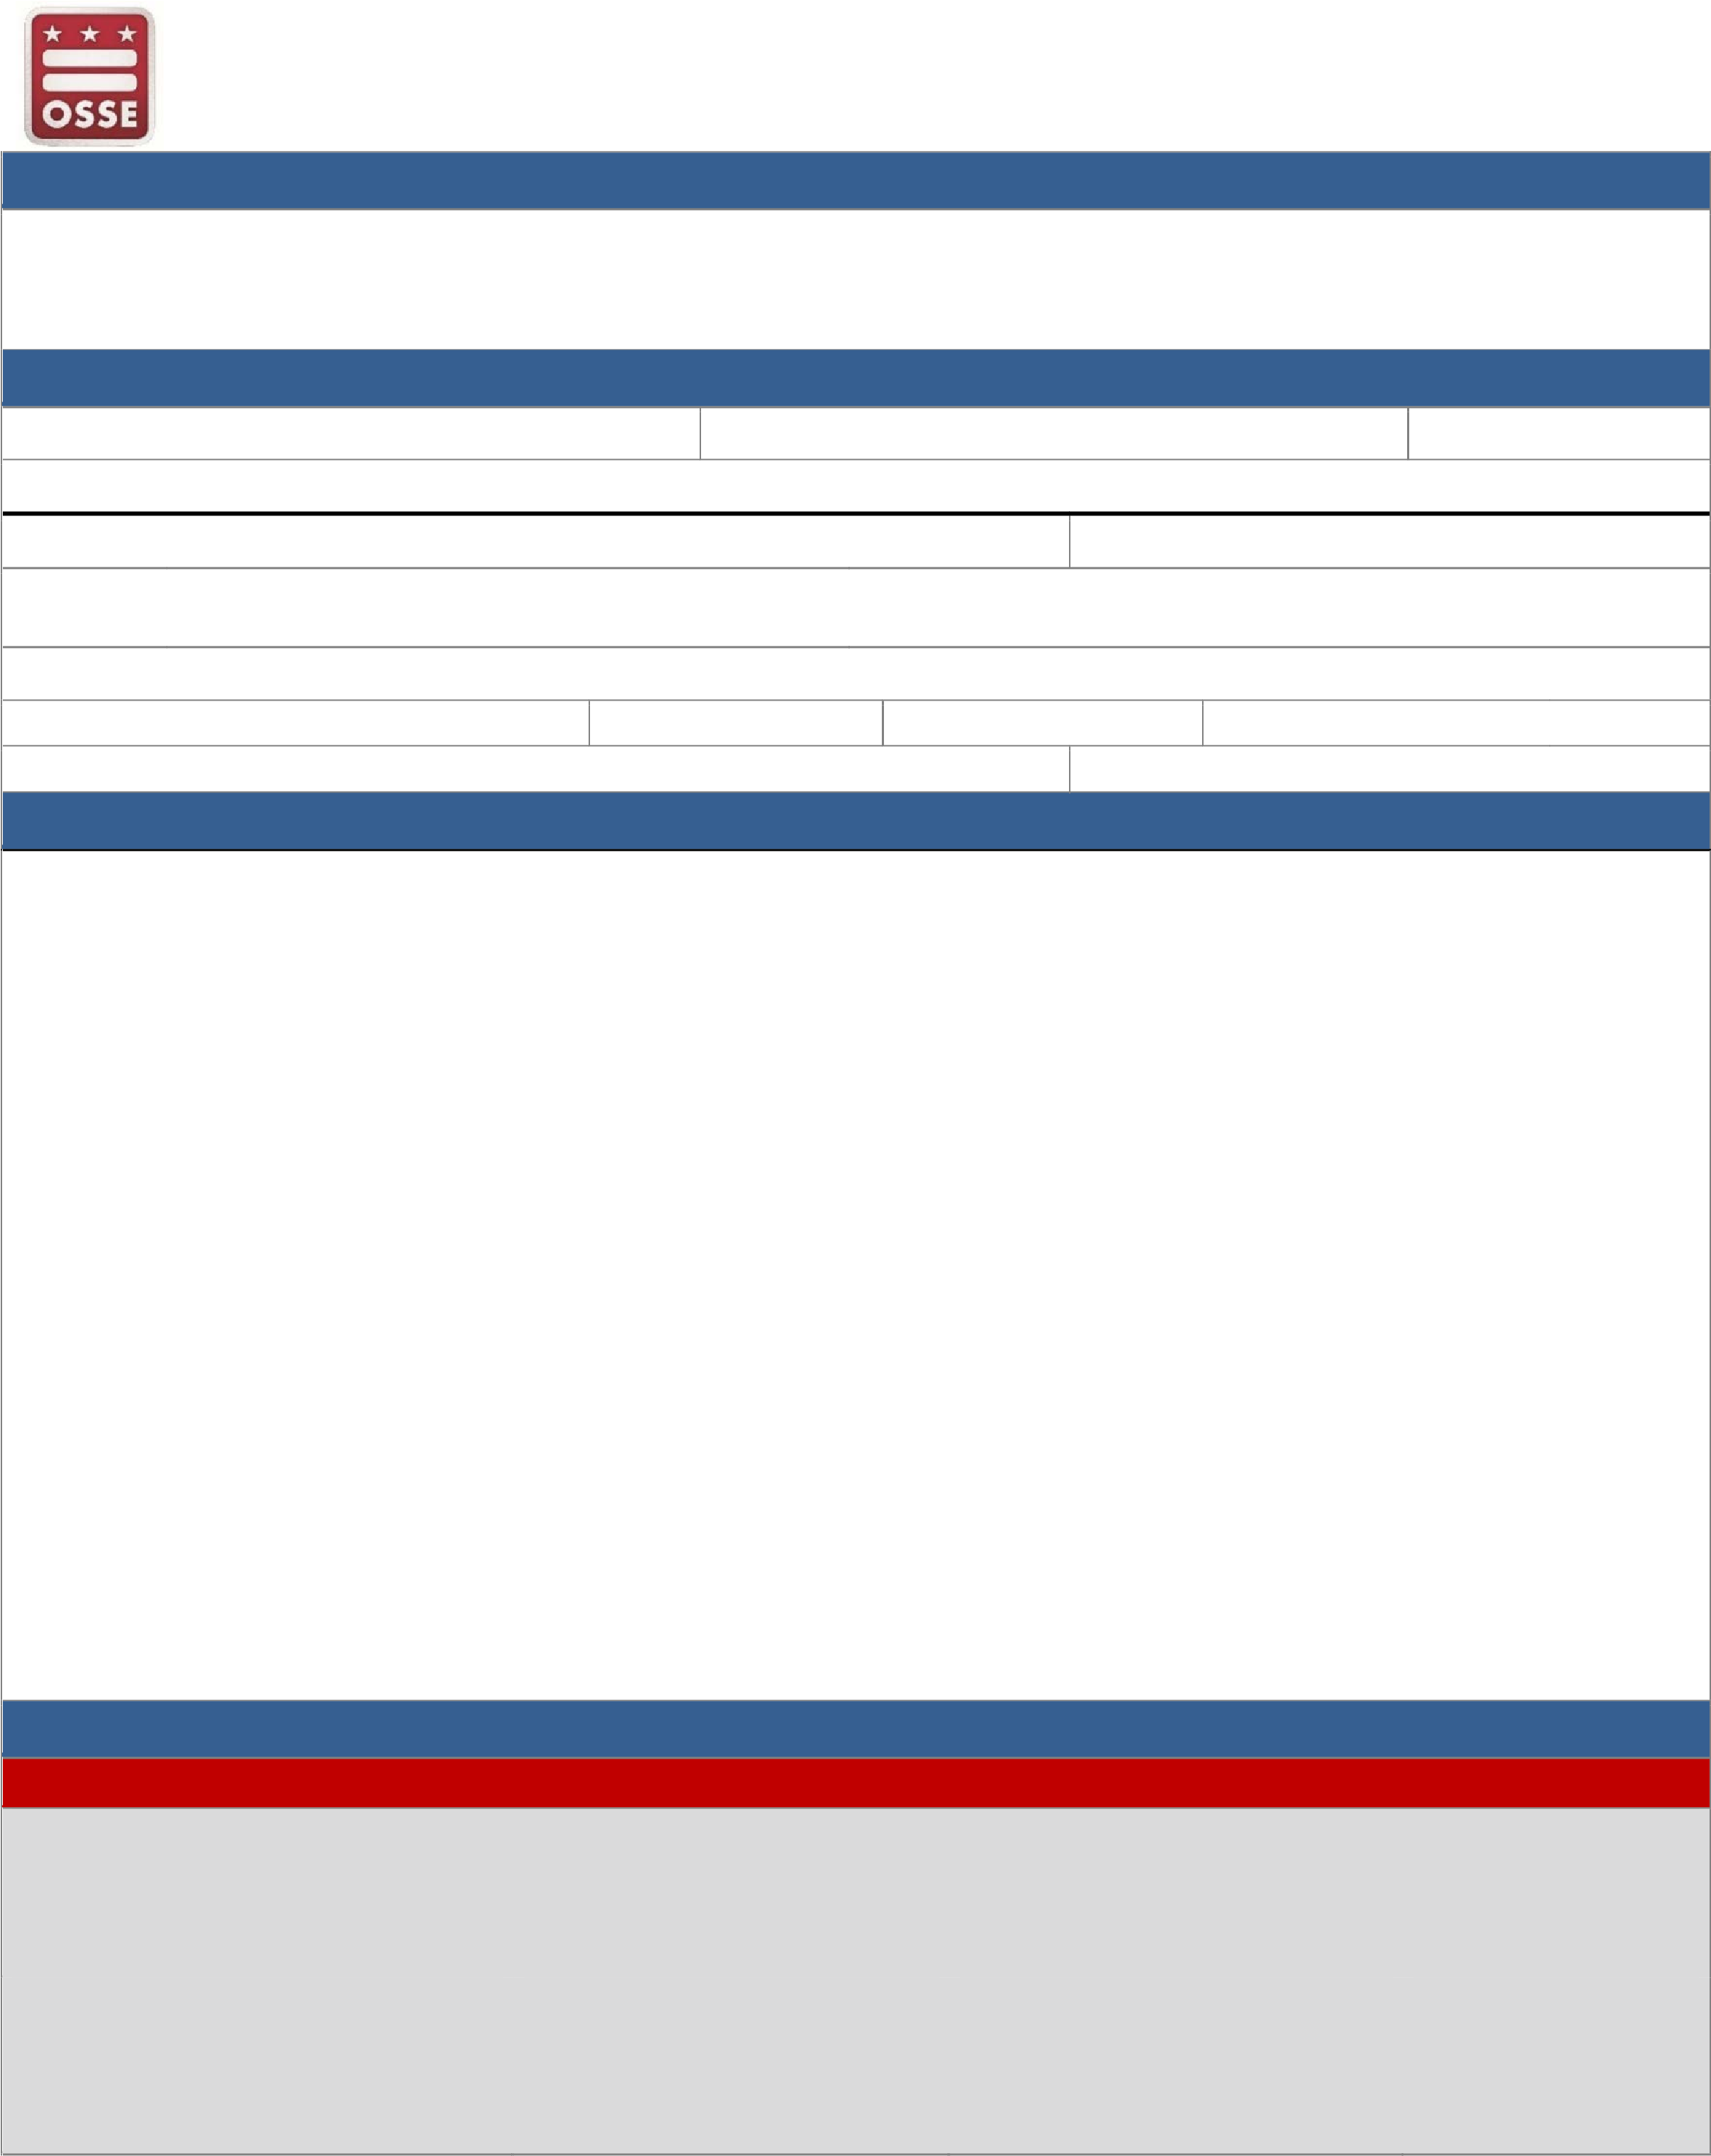I consent to the disclosure of whether I was determined to meet the residency requirements for any government funded financial assistance program (such as, Medicaid, TANF, or SNAP) in which I am enrolled for the sole purpose of verifying District residency for DC public or charter school enrollment. By signing below, I am saying: I authorize OSSE to obtain my personally identifiable DC residency status information from other state or federal agencies, including but not limited to, the DC Department of Human Services (DHS), the DC Housing Authority (DCHA), and the Department of Health Care Finance (DHCF). OSSE will protect my information and follow all applicable laws regarding the protection and use of this information.
* I understand that enrollment of the above-named student in District of Columbia Public Schools, public charter schools, or other schools providing educational services funded by the District of Columbia is based on my representation of **bona-fide DC residency, including this sworn statement of physical presence and my submission of valid and proper documentation verifying residency** or by completion of a tuition agreement and tuition payments.
* I understand that even if the documentation I provide appears to be satisfactory, OSSE or school officials, with reasonable basis, may seek further information to verify the student’s residency or the Other Primary Caregiver status of the adult enrolling the student.
* If the District of Columbia, through OSSE, determines that I am not a resident or an approved non-resident under 5A DCMR § 5007, I understand that I am liable for payment of retroactive tuition for the student, and that the student may be withdrawn from school.
* I understand that if I provide false information or documentation, I can be referred to DC Office of the Inspector General for criminal prosecution or to the DC Office of the Attorney General for prosecution under the False Claims Act and under DC Code § 38-312 which provides that any person who knowingly supplies false information to a public official in connection with student residency verification shall be subject to payment of a fine of not more than $2,000 or imprisonment for not more than 90 days, but not both a fine and imprisonment.
* I understand that this form and all supporting documentation to this form, including all other OSSE forms used to verify residency, will be retained by the school. I consent to their disclosure to OSSE, external auditors, and other District agencies including but not limited to the DC Office of the Inspector General and the DC Office of the Attorney General, upon request, for the purposes of ensuring the accuracy of my District residency.
* I understand that the District of Columbia may use whatever legal means it has at its disposal to verify my residence.
* **I agree to notify the school of any change of residence for myself or the student within three school days of such change and complete a DC Residency Verification Form**.

**Enrolling Person SIGN HERE: ______________________________________________ DATE: ______________ Step Four: Submit this completed form and applicable documentation to your school.**

**SCHOOL OFFICIAL USE ONLY** The following method was used to verify District of Columbia residency. Choose ONE method.

I certify, under the penalties of perjury, that I have personally reviewed all the documents presented and affirm that the information represented above is true to the best of my knowledge, information, and belief. I also affirm that all supporting documentation to this form will be retained by the school and made available to OSSE, external auditors, and other agencies, including but not limited, to the DC Office of the Inspector General and the DC Office of the Attorney General, upon request.

**School Official Name (print)**: __________________________________ **Signature**: _________________________________ **Date**: _______________

**Method A: School official verified**  **Method B: Select one document** **Method B: Select two documents**  **Method C:** Home visit

* OSSE Residency Verified (QLIK, ASPEN, or CBO  Pay stub  DC motor vehicle registration

Subsidy)  DC Gov. financial assistance  DC driver’s license/non-driver ID

* Homeless liaison verified  Certified DC Tax Form-D40  Lease with payment
* Ward of DC  Military housing orders  Utility bill with payment  **Non-resident**
* Embassy letter

*Office of the State Superintendent of Education* | *1050 First St. NE, Washington, DC 20002* | *202.727.6436* [| *osse.dc.gov*](https://osse.dc.gov/)  version 01.24.2023

Page **1** of **2**

|  |  |  |  |
| --- | --- | --- | --- |
| **Enrolling person, follow ONE of the methods (A-C) to verify your DC residency.** | | | |
| A | **Verify with a school official.** If you are experiencing homelessness, a ward of the District, and/or a participant of a District public benefits program, such as Medicaid, Supplementation Nutrition Assistance Program (SNAP), or Temporary Assistance for Needy Families (TANF)– your school may already have your information. Check with your school official or the school’s homeless liaison.    **Verify through the Office of Tax and Revenue (OTR).** Re-enrolling families/students are often able to verify residency using OTR residency verification process. The enrolling person must have paid taxes in DC during the previous fiscal year and have the student’s Social Security number. The student must be re-enrolling in the same local education agency and enrolling in grades K-12. Login to the system a[t ossedctax.com.](https://www.ossedctax.com/) If successful, your verification will then be available for your school to confirm. | | |
| B | **Verify by submitting supporting documentation.** *All* items must include the same name and address of the enrolling person as completed on the DC residency verification form and school-based enrollment documents. | | |
| **ONE item is needed from this list.** | **OR** | **TWO different items are needed from this list.** |
| * A valid **pay stub** issued within 45 days of the school’s review of this form. Must contain withholding of only DC personal income tax for the current tax year and no other states listed for deduction, even if the amount is zero. It must also show a DC personal income tax withholding amount greater than zero for both the current tax year and current pay period. * **Unexpired official documentation of financial assistance from the Government of the District of Columbia,** issued to the enrolling person within the past 12 months and current at the time presented to the school, including, but not limited to, Temporary Assistance for Needy Families (TANF),   Medicaid, the State Child Health Insurance Program (SCHIP), Supplemental Security Income, housing assistance or other programs.   * **Certified copy of Form D40** by the DC Office of Tax and Revenue (OTR), with evidence of payment of DC taxes for the current or most recent tax year and must bear the OTR stamp.      * **Current military housing orders or statement on military letterhead**, must be official correspondence and cite the specific DC address of residence.      * **Embassy letter** issued within the past 12 months. Must contain an official embassy seal and signature of embassy official; and indicate that the enrolling person currently resides, or will reside, on embassy property in DC during the relevant school year. | * **DC motor vehicle operator’s permit** or official government-issued non-driver identification that is valid and unexpired.      * **DC motor vehicle registration** that is valid and unexpired.      * **Lease or rental agreement** that is valid and unexpired **with a separate proof of payment of rent**, such as receipt of payment, money order, or copy of cashed check. *The lease* must contain the start date, monthly rent amount, name of landlord, and be signed by the enrolling person and landlord.   *The separate proof of payment*must be for a period within two months immediately preceding the school’s  review of this form and match the monthly rent amount stated on the lease.     * **Utility bill** (***only gas, electric, and water bills are acceptable***) **with a separate paid receipt showing payment of the bill**, such as receipt of payment printout, money order, or copy of cashed check.   *The utility bill* must be for a period within the two months immediately preceding the school’s review of this form. *The separate proof of payment* must be for the specific bill submitted. The most common submission is two consecutive bills where the second bill shows payment on the first bill. A credited amount on a bill and government agency letter subsidizing payment for utility are also acceptable proofs of payment. |
| C | **Verify through a home visit.** If you are unable to verify through one of the above methods, speak with your school official about a home visit. | | |
| **Enrolling as a non-resident student** | | | |
| Non-resident students are only eligible to attend a District public school if there are no eligible DC residents on the waitlist, the LEA agrees to enroll the student, there is a signed tuition agreement in place with the Office of the State Superintendent of Education, and an initial tuition payment has been made. To complete a tuition agreement and tuition payment, please email osse.residency@dc.gov. Nonresidents are not eligible for enrollment through the District’s Pre-K Enhancement and Expansion Funding Program. | | | |
| **Persons eligible to enroll a student.** | | | |
| * **Parent** - a natural parent, stepparent, domestic partner, or parent by adoption who has custody or control of a student, including joint custody. * **Guardian** - an appointed legal guardian of a student by a court of competent jurisdiction. * **Custodian** - a person to whom physical custody has been granted by a court of competent jurisdiction. * **Other Primary Caregiver** - is a person other than a parent or court-appointed custodian or guardian who is the primary provider of care or control and support to a student who resides with him or her, *and* whose parent, custodian, or guardian is unable to supply such care and support due to serious family hardship. * **Adult Student** - A student who is 18 years of age or older, or who has been emancipated from parental control by marriage, operation of statute, or the order of a court of competent jurisdiction. | | | |

*Office of the State Superintendent of Education* | *1050 First St. NE, Washington, DC 20002* | *202.727.6436* [| *osse.dc.gov*](https://osse.dc.gov/)  version 01.24.2023

Page **2** of **2**

# Sworn Statement – 2023-24 School Year

**This form is to be completed by the person enrolling the student, or by the parent of an adult student or minor parent, in cases when a sworn statement is needed to complete residency verification. For example, use this form in cases where a minor parent is enrolling their child but currently living at home and not able to prove DC residency.**

|  |  |  |  |  |
| --- | --- | --- | --- | --- |
| **Provide information about individual.** | | | | |
| **Student First Name:** | **Student Last Name:** | | | |
| **Person completing sworn statement > First Name:** | | | **Last Name:** | |
| **Address of person completing sworn statement:** | | | | |
| **City:** | **State:** | | | **ZIP:** |
| **Relationship to enrolling student:** | | | | |
| **Email:** | | **Phone:** | | |
| **Identify basis for sworn statement.** | | | | |
| **Check the appropriate basis for the sworn statement:**     * I am the parent, guardian, or custodian of an adult student and the student resides with me at the address provided above. Documents establishing DC residency as set forth in 5A DCMR § 5004.2 are attached.      * I am the parent, guardian, or custodian of a minor parent and the minor parent and child reside with me at the address provided above. Documents establishing DC residency as set forth in 5A DCMR § 5004.2 are attached.      * I am the Other Primary Caregiver (OPC) of the student as attested in the Other Primary Caregiver form. Documents establishing DC residency as set forth in 5A DCMR § 5004.2 are attached. | | | | |
| **Sign and complete the sworn statement.** | | | | |
| I solemnly affirm under the penalties of perjury that the contents of the foregoing are true to the best of my knowledge, information and belief. I further accept that all provisions set forth in “Step Three: Certification of Residency Requirements” on the DC Residency Verification Form are incorporated and merged herein.    **Signature of person completing sworn statement**: ____________________________________ **Date**: _______________ | | | | |

*Office of the State Superintendent of Education* | *1050 First St. NE, Washington, DC 20002* | *202.727.6436* [| *osse.dc.gov*](https://osse.dc.gov/)  version 01.24.2023

Page **1** of **1**

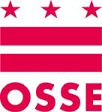

Transitory Services (Education of Homeless Children and Youth Program)

(202) 741-6412

Fax: (202) 741-0227 www.osse.dc.gov

**Title X Part C McKinney-Vento**

**Confidential Referral Form**

School Name: ____________________________________________ Date: _____________________

Student: _________________________________________________ M/F: ____________

Grade: ________ Unique Student Identifier Number (USI):_________________________________

Age: __________ Birth Date: _________________ Phone Number: __________________________

Temporary Address: _____________________________ City: ______________________ Zip: ______

Last School Attended: _____________________________ School ID Number ______________

[School of Origin]

Location of School: ________________ __________________________________________________

[City] [State]

Referring Person: ___________________________________ Position: _________________________

***Please check all that apply for the following areas of concern relevant to the student:***

Night Time Residency Status: You must select one of the following:

|  |  |  |  |
| --- | --- | --- | --- |
| Student lacks a permanent residence ___ | |  | Doubled-Up (living with someone temporarily) ___ |
| Student is unable to pay school fees ___ | |  | Unaccompanied (guardian not with student) ___ |
| Immunizations are needed | ___ |  | Sheltered (living in a community shelter) ___ |
| Excessive absences | ___ |  | Unsheltered (on the streets/unfit building) ___ |
| Lacks academic records/documents | ___ |  | Hotel/Motel ___ |
| Experiencing academic delays | ___ |  |  |
| In need of school supplies | ___ |  |  |
| In need of school transportation | ___ |  |  |
| In need of resource referrals | ___ |  |  |
| In need of medical attention | ___ |  |  |
| In need of clothing/uniforms | ___ |  |  |
| Completed academic assessment | ___ |  |  |
| Possesses a current I.E.P. (SPED) | ___ |  |  |

Services needed:

IDEA ___ LEP/ESL ___ 504 ___ Home Bound ___ Migratory ___ Other: ______________

Other children in the home (list names and ages):____________________________________________

___________________________________________________________________________________

School Based Liaison: _________________________________________________________________

[Name] [Phone]

____ Copy sent to OSSE ____ Copy placed in student’s cumulative record *Return Form to jasent.brown@dc.gov *